

Paediatric Autism Service

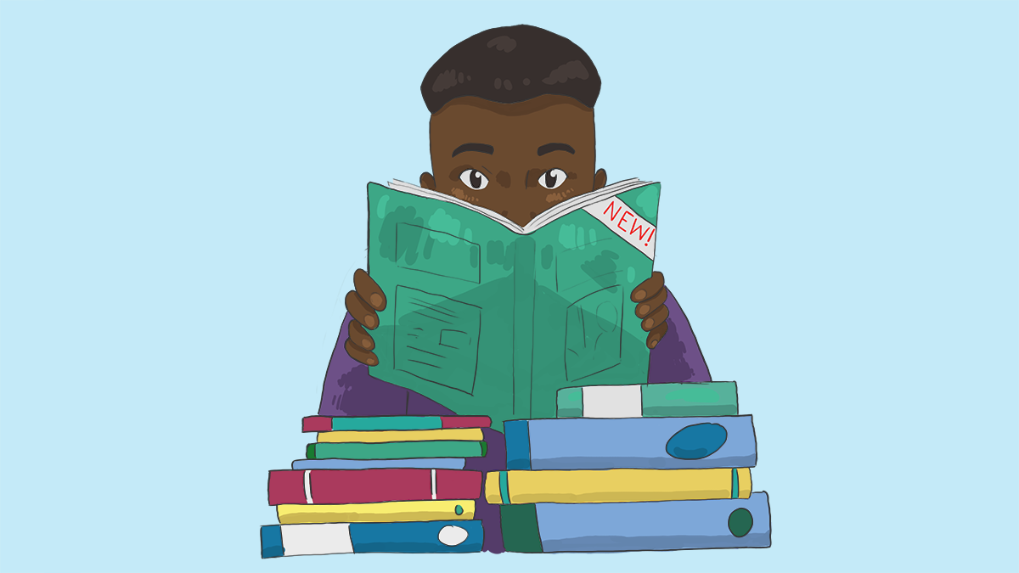

Books about autism for children, teenagers and parents

Introduction

Parents/carers, children & young people often enquire regarding books that are available for autistic children/young people and so this booklet aims to provide information on some the books that are available.

This booklet aims to provide you with a summary of each book but does not advise on the price of the books listed as prices can vary. Some books may be available as e-books or for free on the library app. Please note the Northern Trust & Paediatric Autism Service are NOT recommending these books or advising you to purchase these – this booklet is merely a review of books available as a point of reference.

The following list is not comprehensive, there are many more available. Not all of the books listed may be helpful for your child/young person; it is important to find one that they like and suit their needs.

Books for younger children

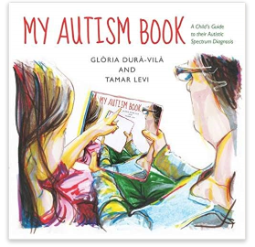
My autism book by Glòria Durà-Vilà and Tamar Levi
My Autism Book is a beautifully illustrated picture book that helps parents to explain an autism diagnosis to their child in a sensitive, positive and accurate way.
When a child is diagnosed with an Autism Spectrum Disorder (ASD), parents often feel overwhelmed and uncertain about how to communicate the diagnosis to their child. This book is designed to be read with the child as a simple introduction to their diagnosis. Written by a doctor and a children's author, the book is tailored precisely to the needs and experiences of the child with ASD aged 5 and up. It explains what an autism diagnosis means and encourages an exploration of the child's likely strengths and differences using clear language that speaks directly to the child. The colourful pictures throughout show how the world looks from the child's perspective and the book ends with a summary checklist to encourage the child to record and discuss how autism affects them.

My awesome autism by Nikki Saunders
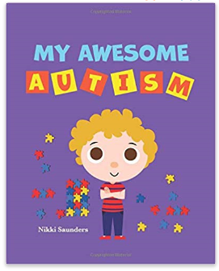
A beautifully, bright and sensory illustrated book! A little boy named Eddie shares his findings about his autism and teaches his readers in a cheerful playful way! Eddie helps all children learn about their autism diagnosis and how “we are all different!” Whether your child receives their diagnosis at toddler age or much later, this wonderful educational tool suits all. It can be an overwhelming time for parents and carers to know when to start to explain to their child, about their autism diagnosis. During this time parents, carers and therapists look for the best way to deliver such love and reassurance! After all autism is a beautiful gift! At the same time, this can be a huge relief for the child to understand that they are truly wonderful as they are, and do not need to adapt to things that do not suit their needs. A fantastic communicational gateway between the child and the parents/caregivers. It helps to open up the subject in a gentle and nurturing way, to revisit at any time the child is ready and build upon their experiences with you! . The colourful, eye catching illustrations are carefully designed in simple 2D characters, sensory colours with simple contrast and clear short sentences allowing space to process in the child’s own time. A beautiful beginning as this book was first made for my son, then blossomed to help children and families all over the world!

My superhero brain by Christel Land
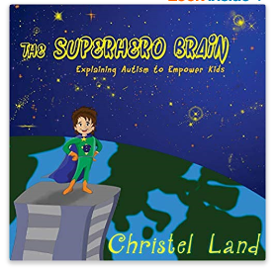
This story speaks to children who have autism and explains to them what it means in a way that leaves them feeling empowered and able to make their dreams come true. The story refers to sensory issues as "special powers" and explains how living with autism can be awesome and at the same ti me also feel tricky sometimes. The Superhero Brain is written by a mother to her autistic son. The story was initially only intended to be for her son, to help him better understand himself, but has since turned in to a book available for everyone to share with their children. To help your child relate to the message in this story, the book is available with several different characters. The book is part of a series, and if your family is living with autism, you may also want to look at Christel Land's other title "The Superhero Heart", which explains living with autism to brothers and sisters in the same empowering, magical way.

Different like me by Jennifer Elder
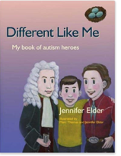
Different Like Me introduces children aged 8 to 12 years to famous, inspirational figures from the world of science, art, math, literature, philosophy and comedy. Eight-year-old Quinn, a young boy with Asperger's Syndrome, tells young readers about the achievements and characteristics of his autism heroes, from Albert Einstein, Dian Fossey and Wassily Kandinsky to Lewis Carroll, Benjamin Banneker and Julia Bowman Robinson, among others. All excel in different fields but are united by the fact that they often found it difficult to fit in-just like Quinn.
Fully illustrated in colour and written in child-friendly language, this book will be a wonderful resource for children, particularly children with autism, their parents, teachers, carers and siblings

ASD and me by Teresa DeMars
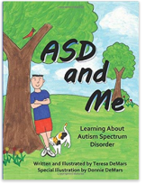
Written for kids diagnosed with Asperger’s Syndrome, or autism, parents will appreciate the way this heart-warming children's picture book will help them explain Autism Spectrum Disorder (ASD) to their child on the spectrum. ASD and Me is written from the point of view of Eli, a seven-year-old boy who has ASD. Through the story, Eli explains how he was diagnosed, and how ASD affects the way he thinks and interprets the world around him. He also talks about some of the social and life skills he has learned that help him fit in with others. The story concludes with some of the interests and activities Eli shares with other children. ASD and Me is a great book to help introduce the subject of autism to siblings, classmates, extended family and to those on the spectrum.

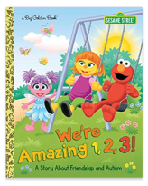
We’re amazing 1,2,3 (sesame street) by Leslie Kimmelman
We're Amazing 1,2,3! is the first Sesame Street storybook to focus on autism, which, according to the most recent US government survey, may, in some form, affect as many as one in forty-five children. It's part of Sesame Street's autism initiative that has expanded to include a new character with autism. Elmo introduces his long-time friend Julia to Abby, who's a little confused at first because Julia isn't say ing hello. Elmo explains that Julia has autism, so she does things a little differently. Julia sometimes avoids direct eye contact, flaps her arms when she's excited, and is sensitive to some noises. But Abby soon learns that she also has a lot of things in common with Julia. All kids want love, friendship, and to have fun! They are all wonderful, each in his or her own way.

Autism is … (volume one) by Ymkje Wideman-van der Laan
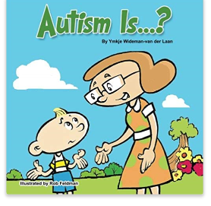
Logan overhears his grandma tell her friend he has autism, and he asks her, “Autism is...?” She explains it to him in this beautifully illustrated story. Someone wisely said, “If you have met one person with autism, you have met one person with autism.” The characteristics are different with each unique individual, and so are the ways to interact, teach, and care for them. You may or may not wish to explain the term autism to your child at a young age, but if you do, I hope this book can help make it easier for you, as it did for me when explaining autism to Logan. His inquisitive mind wanted to know, and once he read this story, even before it was illustrated, he was satisfied with the answer.

Nathan’s autism spectrum superpowers by Lori Leigh Yarborough
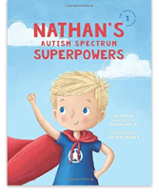
The superhero of this book, Nathan, explains about his Autism Spectrum Superpowers, how they affect him, and ways his friends can help when his superpowers spiral out of control. This book is a tool to help children and their friends, families and caregivers understand kids with superpowers. All children need to know they're wanted, loved and special. All children need to know they have superpowers. And all children especially need to know they're wonderfully made. The author, Lori Leigh Yarborough, is a physical therapist and graduate from the University of Oklahoma Health Sciences Centre. She makes her home in Texas with her husband and their four children. Her second son, Nathan, was diagnosed on the Autism Spectrum with Asperger’s when he was little. She came up with a creative way to explain to Nathan why he didn't respond to things like other kids did. After she told Nathan about his "Supersonic Hearing" he was so excited to finally understand in a way that made sense why things were so loud and overwhelming to him. He wanted to know ALL his superpowers. So, she wrote this book for him. Each superpower has a "helpful hints for friends" section that was originally written for Nathan's siblings and friends to know how help him out when his superpowers took over. This is the first book in the ONE THREE NINE INSPIRED series. Each book is written about a specific child in corroboration with his or her parents. The information given is about that child’s superpowers but will be relatable to other children with the same diagnosis and abilities.
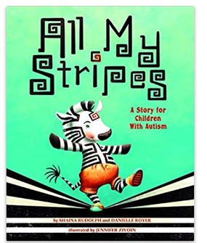
All my stripes by Shaina Rudolph and Danielle Royer
In All My Stripes, Zane the zebra feels different from the rest of his classmates. He worries that all they notice about him is his “autism stripe”. With the help of his Mama, Zane comes to appreciate all his stripes — the unique strengths that make him who he is!

Includes a Reading Guide with additional background information about autism spectrum disorders and a Note to Parents and Caregivers with tips for finding support.

The butterfly’s journey by Heather Porazzo
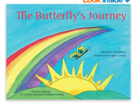
Spring is an exciting time for new beginnings, but when Baby Butterfly does not emerge from his cocoon on time, his parents know something is wrong. Mama and Papa Butterfly seek help from their forest friends and find out that Baby Butterfly has autism. They learn from their animal friends what autism is, what to expect, and how to best help Baby Butterfly. Through the support of his parents and teachers, Baby Butterfly slowly emerges from his cocoon and learns to navigate in the big, beautiful, and often over-stimulating world.

The Butterfly's Journey is an engaging and interactive story that explains Autism Spectrum Disorder (ASD) in an easy-to-understand manner. This delightful story highlights some of the common traits and challenges for those with autism as it delivers a nurturing message about love, support, friendship, and acceptance. Children will enjoy a shape/definition matching game as well as finding the hidden butterfly character on every page while they learn about Baby Butterfly's journey from inside his little cocoon, through his brave flight through the rainbow of challenges, to a happy life where he is embraced and accepted into the community of butterflies
Hello roar little dinosaur by Hazel Reeves
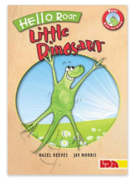
This is the first title in a beautiful new series of picture books launches Roar, the brave and strong little dinosaur who knows it's okay to do things differently. Roar books and resources have been specially created to help children with high-functioning Autism/Asperger's Syndrome and those who live and work with them. Just like Roar, children with autism think in a different way. This enchanting storybook invites children, parents, carers and teachers to celebrate the strengths of children with Asperger's. Roar has many great qualities including honesty, determination, attention to detail, exceptional memory and a sense of humour. Roar helps children move from feeling, 'I've got it wrong!' to saying, 'This is me. I'm okay.' Roar is the main character in this series of books, alongside a family member and occasionally a supportive friend. She uses her special talents and likes to be busy, but enjoys taking a break by hiding - just as children with Asperger's find joining in can be hard work and like to take a break, perhaps by doing a simple activity on their own; routine and ritual restore an overloaded mind.

Noah chases the wind by Michelle Worthington
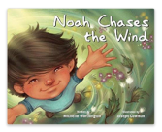
A magical adventure that celebrates the inquisitiveness of children. Noah knew he was different. He could see things that others couldn't, like the patterns in the dust that floated down on sunbeams.
Noah sees, hears, feels, and thinks in ways that other people don't always understand, and he asks a lot of questions along the way. Noah loves science, especially the weather. His books usually provide him with the answers he needs, until one day, there's one question they don't answer - “where does the wind go?”

Filled with rich, sweeping illustrations, this picture book celebrates the inquisitive nature of all children, including those on the autism spectrum. The book contains a page of information for parents, caregivers, and educators about the importance of helping children feel good about their differences.

The girl who thought in pictures by Julia Finely Mosca
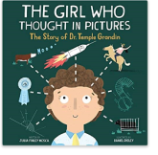
When young Temple was diagnosed with autism, no one expected her to talk, let alone become one of the most powerful voices in modern science. Yet, the determined visual thinker did just that. Her unique mind allowed her to connect with animals in a special way, helping her invent ground-breaking improvements for farms around the globe!

The Girl Who Thought in Pictures: The Story of Dr Temple Grandin is the first book in a brand new educational series about the inspirational lives of amazing scientists. In addition to the illustrated rhyming tale, you’ll find a complete biography, fun facts, a colourful timeline of events, and even a note from Temple herself!

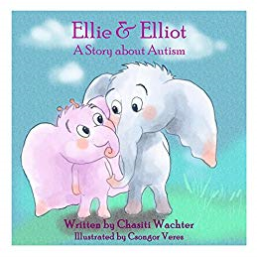
Ellie and Elliot by Chasiti Wachter
Join Ellie as she takes you on the journey of her brother Elliot’s Autism from his difficulties to his triumphs. Step into her world and see what everyday life is like living with a brother with a disability
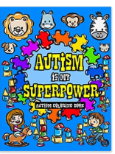
Autism colouring book by Made you smile press
This beautiful Autism Colouring Book is the perfect way to light it up blue and empower autistic children. Not only that, but this motivating colouring book is filled with inspirational quotes and cute animal illustrations to help spread good vibes and encourage creativity.

Books for older children

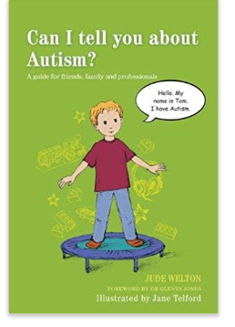

Can I tell you about Autism? By Jude Welton
Meet Tom - a young boy with autism. Tom invites readers to learn about autism from his perspective, helping them to understand what it is and explaining the challenges he faces with issues such as social communication, sensory overload and changes in his routine. Tom tells readers about all the ways he can be helped and supported by those around him.

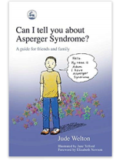
Can I tell you about Asperger’s? By Jude Welton
Meet Adam - a young boy with AS. Adam invites young readers to learn about AS from his perspective. He helps children understand the difficulties faced by a child with AS - he tells them what AS is, what it feels like to have AS and how they can help children with AS by understanding their differences and appreciating their many talents.

Asperger syndrome, the universe and everything by Kenneth Hall
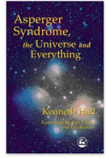
Kenneth Hall was diagnosed with Asperger Syndrome at the age of eight. His early school years had been difficult, as although he is bright and articulate, his behaviour could be challenging and easily misread. After his diagnosis, the Local Education Board intervened and provided him with a laptop computer, to encourage him to express himself. This book is the result. Kenneth is in a unique position to describe some of the inner experiences and perceptions of autism in childhood. He has a warm and positive attitude to Asperger Syndrome which other children will find inspiring. Insights, struggles and joys are recounted vividly in a frank and humorous way. His book is for anyone interested in understanding more about autism, including parents, siblings, teachers and professionals.

The Asperger’s children’s toolkit by Francis Musgrave
Growing up with Asperger Syndrome (AS) can throw up all sorts of challenges, but never fear, The Brain Guru, The Sensory Detective and The Social Scientist are here to help!

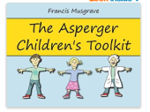
These likeable characters guide children with AS through some of the trickiest, stickiest conundrums known to humankind: from anxiety and negative thinking, to sensory overload, emotions, friendship and trust and social situations. By working through the activities and using the cut-out-and-keep tools with a parent, carer or teacher, children with AS will learn how to build upon their strengths and develop techniques for coping with areas of difficulty - as well as how to handle setbacks and celebrate successes along the way! The important topic of staying safe in the digital world is also covered, providing children with the knowledge and know-how they need to use the internet, social networking and text messaging safely

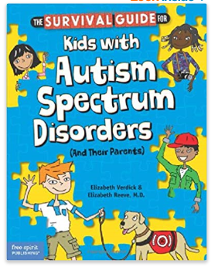
Survival guide for kids with autism spectrum disorders by Elizabeth Verdick and Elizabeth Reeve
This positive, straightforward book offers kids with autism spectrum disorders (ASDs) their own comprehensive resource for both understanding their condition and finding tools to cope with the challenges they face every day. Some children with ASDs are gifted; others struggle academically. Some are more introverted, while others try to be social. Some get "stuck" on things, have limited interests, or experience repeated motor movements like flapping or pacing ("stims"). "The Survival Guide for Kids with Autism Spectrum Disorders "covers all these areas, with an emphasis on helping children gain new self-understanding and self-acceptance. Meant to be read with a parent, the book addresses questions ("What's an ASD?" "Why me?") and provides strategies for communicating, making and keeping friends, and succeeding in school. Body and brain basics highlight symptom management, exercise, diet, hygiene, relaxation, sleep, and toileting. Emphasis is placed on helping kids handle intense emotions and behaviours and get support from family and their team of helpers when needed. The book includes stories from real kids, fact boxes, helpful checklists, resources, and a glossary. Sections for parents offer more detailed information.

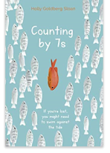
Fiction books

Counting by 7’s by Holly Goldberg Sloan (fiction)
COUNTING BY 7S tells the story of Willow Chance, a twelve-year-old genius who is obsessed with diagnosing medical conditions and finds comfort in counting by 7s. It has never been easy for her to connect with anyone other than her adoptive parents, but that hasn't kept her from leading a quietly happy life . . . until now.

Superstar by Mandy Davis (Fiction)
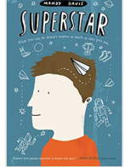
Perfect for fans of Fish in a Tree and Wonder, this uplifting debut novel from Mandy Davis follows space-obsessed Lester Musselbaum as he experiences the challenges of his first days of public school: making friends, facing bullies, finding his "thing," and accidentally learning of his autism-spectrum diagnosis. Lester's first days as a fifth grader at Quarry Elementary School are not even a little bit like he thought they would be--the cafeteria is too loud for Lester's ears, there are too many kids, and then there's the bully.

Lester was always home-schooled, and now he's shocked to be stuck in a school where everything just seems wrong. That's until he hears about the science fair, which goes really well for Lester! This is it. The moment where I find out for 100 percent sure that I won. But then things go a bit sideways, and Lester has to find his way back. A touching peek into the life of a sensitive autism-spectrum boy facing the everydayness of elementary school, Superstar testifies that what you can do isn't nearly as important as who you are.

Books for teenagers

Nonfiction books
Can I tell you about Asperger’s? By Jude Welton
Meet Adam - a young boy with AS. Adam invites young readers to learn about AS from his perspective. He helps children understand the difficulties faced by a child with AS - he tells them what AS is, what it feels like to have AS and how they can help children with AS by understanding their differences and appreciating their many talents.

Freaks, geeks and Asperger syndrome: a user guide to adolescence by Luke Jackson
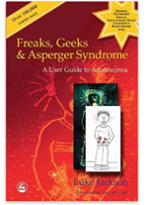
Have you ever been called a freak or a geek? Have you ever felt like one? Luke Jackson is 13 years old and has Asperger Syndrome. Over the years Luke has learned to laugh at such names but there are other aspects of life which are more difficult. Adolescence and the teenage years are a minefield of emotions, transitions and decisions and when a child has Asperger Syndrome, the result is often explosive. Luke has three sisters and one brother in various stages of their adolescent and teenage years, but he is acutely aware of just how different he is and how little information is available for adolescents like himself. Drawing from his own experiences and gaining information from his teenage brother and sisters, he wrote this enlightening, honest and witty book in an attempt to address difficult topics such as bullying, friendships, when and how to tell others about AS, school problems, dating, relationships and morality. Luke writes briefly about his younger autistic and AD/HD brothers, providing amusing insights into the antics of his younger years and advice for parents, carers and teachers of younger AS children. However, his main reason for writing was because so many books are written about us, but none are written directly to adolescents with Asperger Syndrome.
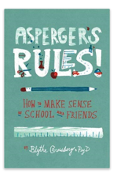
Asperger’s rules by Blythe Grossberg
Fitting in to school and social life can be the single most challenging task when you have Asperger's syndrome. Asperger's Rules! can help. Packed full of information, this book covers common school situations and the uncommon challenges that they can present to a child with Asperger's. Kids will find the how-to for understanding and communicating with peers and teachers, standing up for and taking care of themselves, setting realistic goals, and making friends.
*This is an American book and may have American terminology

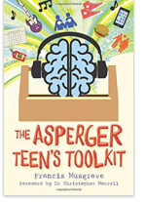
The Asperger teen’s tool kit by Francis Musgrave
Dealing with the everyday realities facing teens with Asperger Syndrome, this book presents a toolkit of tried-and-trusted ideas to help them work through difficulties and find the solutions that work best for them. This book covers everything they need to know to thrive in their adolescent years, including how to hack your own internal alarm system to overcome anxiety and other difficult emotions. It also arms teenagers with everything they need to navigate sexuality and relationships, develop a healthy self-image, deal with bullies, be smart with money and stay savvy online... In short, no issue is left unexplored.
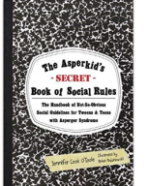
The Asperkid’s (Secret) Book of Social Rules: The Handbook of Not-so-Obvious Social Guidelines for Tweens and Teens with Asperger Syndrome by Jennifer Cook O’Toole
Being a teen or tween isn't easy for anyone - but it's especially tough for Asperkids. I know. I was one, I taught a whole bunch, and I am going to be raising three! That's also why I know that Asperkdis deserve their very own guide to all the hidden social rules that are awfully confusing to us, even if they seem obvious to everyone else. "The Asperkids' (Secret) Rule Book of Social Rules" This isn't your momma's Emily Post, and there is no "don't do this" finger-wagging or patronizing "high and mighty preaching" here. Instead, the "Secret" Book gives Asperkids (aged 10-17) respectful, funny insights written "for Aspies by an Aspie" Chock full of illustrations, logic and even a practice session or six (in comic strip style, thank you very much), this is the handbook every adult Aspie wishes we'd had growing up, but never did.

For boys
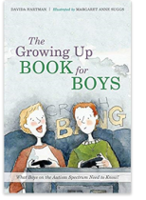
The Growing Up Book for Boys by David Hartman
The Growing Up Book for Boys explains the facts behind the growth spurts, body changes and mood swings of adolescence for boys aged 9-14 on the autism spectrum.

The pre-teen and teenage years are a confusing time when bodies start acting with a will of their own, friendships change and crushes start to develop. Using direct literal language and cool colour illustrations, this book tells boys all they need to know about growing hair in new places, shaving, wet dreams and unexpected erections. It's full of great advice on what makes a real friend, how to keep spots away, and how to stay safe online. Most importantly, it explains that everybody is amazing and unique and encourages young boys with autism to celebrate difference!

What's Happening to Tom? By Kate E. Reynolds
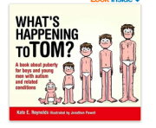
Tom notices that his body is changing. Tom's voice is different and hair is growing in new places. There are other changes happening too. Tom learns that he has started growing into a man.

Following Tom as he begins to notice changes to his body, this simple resource helps parents and carers teach boys with autism or other special needs about puberty. It covers all the changes that they will experience, both emotional such as new feelings and physical such as wet dreams. This fully illustrated positive and entertaining book provides the perfect opportunity to talk about puberty with boys and young men with autism or special needs.

For girls

The Growing Up Guide for Girls by David Hartman
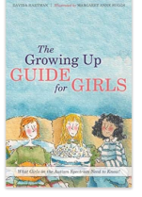
The Growing Up Guide for Girls is a one-stop guide for young girls on the autism spectrum explaining all they need to know about puberty and adolescence.
The pre-teen and teenage years are a bumpy time when bodies change, emotions are high and peers are developing at different paces. Using simple, literal language and delightful colour illustrations, this book explains the facts about body changes such as growing hair in new places, periods, wearing a bra and keeping spots away! It gives cool tips on what makes a real friend, what it means to have a crush on somebody, and how to stay safe online. Most importantly, it explains that everybody is beautiful and unique and encourages young girls with autism to celebrate difference! Perfect preparation for the teenage years for girls aged 9-14.

What’s happening to Ellie by Kate E. Reynolds
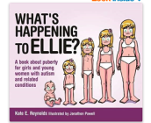
Ellie notices that her body is changing. Hair is growing in new places and there are other changes happening too. Ellie's mum helps her understand that she has started growing into a woman.

Following Ellie as she begins to notice changes to her body, this simple resource helps parents and carers teach girls with autism and related conditions about puberty. It covers all the changes that they will experience, both emotional such as new feelings and physical such as periods. This fully illustrated positive and entertaining book provides the perfect opportunity to talk about puberty with girls and young women with autism or related conditions.

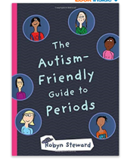
The autism friendly guide to periods by Robyn Steward
Written by autistic author Robyn Steward, this is a detailed guide for young people aged 9 to 16 on the basics of menstruation. Created in consultation with young people, an online survey and a group of medical professionals, this is a book that teaches all people about periods, which can be a scary and overwhelming issue. Promoting the fact that everyone either has periods or knows someone who does, the book reduces the anxiety girls face in asking for h elp. It offers direct advice on what periods look and feel like and how to manage hygiene and pain. It also breaks up information using flaps and step-by-step photos of how to change pads and tampons; it discusses alternatives to tampons and pads, and gives information about possible sensory issues for people with autism.

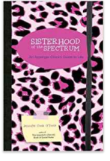
Sisterhood of the spectrum: an Asperger’s chick’s guide to life by Jennifer Cook O’Toole
Spectrum gals, ever wished you had a handbook to help navigate the confusing world of teenage girlhood? Look no further! Aspie-in-the-know, Jennifer Cook O'Toole provide just that with her inspirational guide to life for teenage girls with Asperger syndrome. Drawing on her own, real-life experiences rather than preaching from textbooks, she covers everything you need (and want!) to know, from body shapes and love interests to bullying, friendships and how to discover and celebrate your unique, beautiful self. With illustrations by an Aspie teen and inspirational quotes from well-known, female Aspie voices, including Temple Grandin, Rudy Simone, Robyn Steward, and Haley Moss, Sisterhood of the Spectrum is your perfect companion on the "yellow brick road" to womanhood. It will leave you empowered, informed and excited to be different.

Aspergirls by Rudy Simone
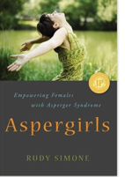
Girls with Asperger's Syndrome are less frequently diagnosed than boys, and even once symptoms have been recognised, help is often not readily available. The image of coping well presented by AS females of any age can often mask difficulties, deficits, challenges, and loneliness.

This is a must-have handbook written by an Aspergirl for Aspergirls, young and old. Rudy Simone guides you through every aspect of both personal and professional life, from early recollections of blame, guilt, and savant skills, to friendships, romance and marriage. Employment, career, rituals and routines are also covered, along with depression, meltdowns and being misunderstood. Including the reflections of over thirty-five women diagnosed as on the spectrum, as well as some partners and parents, Rudy identifies recurring struggles and areas where Aspergirls need validation, information and advice. As they recount their stories, anecdotes, and wisdom, she highlights how differences between males and females on the spectrum are mostly a matter of perception, rejecting negative views of Aspergirls and empowering them to lead happy and fulfilled lives.

This book will be essential reading for females of any age diagnosed with AS, and those who think they might be on the spectrum. It will also be of interest to partners and loved ones of Aspergirls, and anybody interested either professionally or academically in Asperger's Syndrome.

How to be human the diary of an autistic girl by Florida Frencz
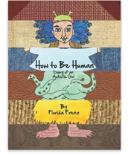
With powerful words and pictures Florida Frenz chronicles her journey figuring out how to read facial expressions, how to make friends, how to juggle all the social cues that make school feel like a complicated maze. Diagnosed with autism as a two-year-old, Florida is now an articulate 15-year-old whose explorations into how kids make friends, what popularity means, how to handle peer pressure will resonate with any pre-teen. For those wondering what it's like inside an autistic child's head, Florida's book provides amazing insight and understanding. Reading how she learns how to be human makes us all feel a little less alien. A teacher guide is available on the Creston website for compassion/empathy curriculum and for modelling journal writing and print copies for major conferences.

Fiction books
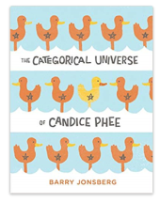
The categorical universes of Candice Phee by Barry Jonsberg (Fiction)
Candice Phee isn't a typical twelve-year-old girl. She has more than her fair share of quirks, but she also has the very best of intentions and an unwavering determination to make sure everyone around her is happy. That includes you. Because you'll laugh out loud reading this charming, lovable novel. Candice's task is no easy feat when she's dealing with a pet fish with an identity crisis, a friend who believes he came from another dimension, an age-old family feud, and a sick mom. But she is on a mission! Her methods might be unique, but Candice will do whatever it takes to restore order to her world and make sure everyone is absolutely, categorically happy again.

The reason I jump by Naoki Higashida (Fiction)
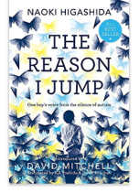
Written by Naoki Higashida when he was only thirteen, this remarkable book provides a rare insight into the often baffling behaviour of autistic children. Using a question and answer format, Naoki explains things like why he talks loudly or repeats the same questions, what causes him to have panic attacks, and why he likes to jump. He also shows the way he thinks and feels about his world - other people, nature, time and beauty, and himself. Abundantly proving that people with autism do possess imagination, humour and empathy, he also makes clear how badly they need our compassion, patience and understanding.
David Mitchell and his wife have translated Naoki's book so that it might help others dealing with autism and generally illuminate a little-understood condition. It gives us an exceptional chance to enter the mind of another and see the world from a strange and fascinating perspective.
The book also features eleven original illustrations, inspired by Naoki's words, by the artistic duo Kai and Sunny.

Books for siblings

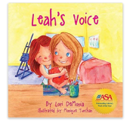
Leah’s voice by Lori Demonia
Leah's Voice is a story that touches on the difficulties children encounter when they meet a child with special needs such as autism. Children who have a brother or sister with special needs may find it difficult to explain to their friends or feel disappointed when their friends aren't more understanding. Leah's Voice tells the story of two sisters facing these challenges. Through her kindness and devotion, one sister teaches by example the importance of including everyone and showing acceptance.
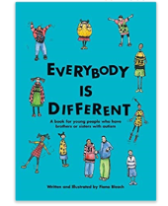

Everybody is different by Fiona Bleach
This book gives answers to the many question’s brothers and sisters of young people on the autism spectrum have about their siblings. In addition to explaining in basic terms the characteristics of autism, this little book is full of helpful suggestions for making family life more comfortable for everyone.

Autism in my family by Sandra Tucker
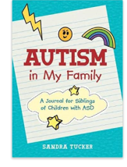
The relationship between siblings can be tough, and the sibling dynamic can be further challenged when one child has autism. This interactive workbook is designed for siblings of children with autism. Introducing the experience of autism in simple language, children are encouraged to complete activities that identify differences and strengthen relationships. This book is focussed on understanding and supporting a sibling while developing individual emotions and identity. The pages are designed to be drawn on and personalized by the child. Ideal for young children aged 8-12 who have a sibling with autism, the activities can be completed with a parent's guidance or on their own. Full of resources, strategies, and exercises, this workbook can support professionals working with children and facilitate healthy sibling relationships.

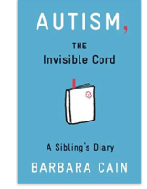
Autism the invisible cord by Barbara Cain
Ezra looks like any other sixth grader with faded jeans, turned around cap and a mess of chestnut curls. You see, my brother is like any other eleven-year-old…except when he isn't. Autism, The Invisible Cord; follows 14-year-old Jenny as she describes her day-to-day life with her younger autistic brother, Ezra. Ezra can be both her best friend as well as her biggest obstacle to living a ""normal life,"" and Jenny often finds herself stuck worrying about her younger brother. Through taking care of Ezra and a very special school project, Jenny ends up learning about her own character and strengths, and a way to shine despite everything else.

Books for parents

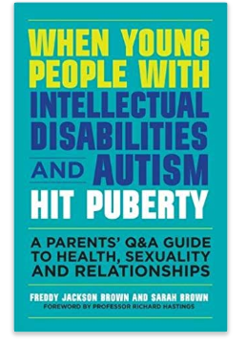
When Young People with Intellectual Disabilities and Autism Hit Puberty by Freddy Jackson Brown and Sarah Brown
Puberty, personal hygiene and sex can be difficult topics to broach with your child, especially when they have an intellectual disability or autism. The authors of this guide provide honest answers to challenging questions and provide solutions to the dilemmas that many parents face on a daily basis. Structured around issues related to puberty and emerging sexuality in children with disabilities or autism, such as physical changes, mood swings and sexual behaviour, the book presents case studies alongside practical guidance on how to overcome problems that commonly arise.
The book also explains laws relevant to disability and sexuality and suggests appropriate sex education programmes to meet the needs of differing degrees of disability.

101 games and activities for children with Autism, Asperger’s and Sensory processing disorders by Tara Delaney
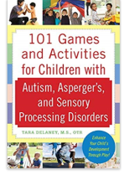
One of the best ways for children with autism, Asperger's, and sensory processing disorders to learn is through play. Children improve their motor skills, language skills, and social skills by moving their bodies and interacting with their environment. Yet the biggest challenges parents, teachers, and loved one’s face with children on the autism spectrum or with sensory processing disorders is how to successfully engage them in play.
Paediatric occupational therapist Tara Delaney provides the answer. In 101 Games and Activities for Children with Autism, Asperger's, and Sensory Processing Disorders, she shows you how to teach your children by moving their bodies through play. These interactive games are quick to learn but will provide hours of fun and learning for your child. And many of the games can be played indoors or outdoors, so your child can enjoy them at home, outside, or on field trips.
More than one hundred games that help your child:
- make eye-contact, stay focused, and strengthen his or her motor skills
- associate words with objects and improve language and numerical skills
- learn how to interact with others, how to take turns, and other social skills needed for attending preschool and school

All cats have Asperger syndrome by Kathy Hoopmann
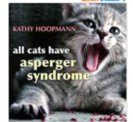
All Cats Have Asperger Syndrome takes a playful look at Asperger Syndrome (AS), drawing inspiration from the feline world in a way that will strike a chord with all those who are familiar with AS. Delightful colour photographs of cats bring to life familiar characteristics such as sensitive hearing, scampering at the first sign of being stroked, and particular eating habits. Touching, humorous and insightful, this book evokes the difficulties and joys of raising a child who is different and leaves the reader with a sense of the dignity, individuality, and potential of people with AS. This engaging book is an ideal, gentle introduction to the world of AS.

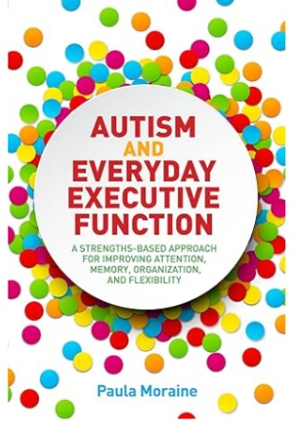
Autism and Everyday Executive Function: A Strengths-Based Approach for Improving Attention, Memory, Organization and Flexibility
Understand and support executive function in individuals with Autism Spectrum Disorder (ASD) with this fully-explained, innovative model. Showing how to use an individual's strengths to address executive functioning weaknesses, this approach will also help to build a strong foundation for social and communication skills.
Advocating a person-centred approach, the author describes the importance of identifying the individual's preferred style of engagement and communication, and how sensory experiences impact their thoughts, feelings, and actions. She explains how to use this information to identify the individual's strengths and weaknesses across eight key areas which are the building blocks of executive functions: attention; memory; organization; time management; initiative; behavior; goal setting and flexibility. These areas can be used daily to establish predictability and offer a foundation for interpreting, processing and understanding the world with flexibility. Professionals and parents can also use them as the basis of an Individualized Education Plan (IEP), or to create personalized interventions and support at school or at home.

Books about Masking
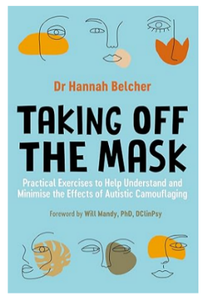

Taking Off the Mask: Practical Exercises to Help Understand and Minimise the Effects of Autistic Camouflaging

'I realised I had been camouflaging my whole life - I'd been trying to mask my autistic traits and fit in with all the non-autistic people around me.'
Growing up autistic can often feel as though you have to become a chameleon in social situations, camouflaging yourself to fit in with a seemingly neurotypical world. Combining lived experience with scientific research and practical advice, this book is the essential guide to understanding why you mask and how to feel confident without one.
Focusing on diagnostic devices like the Camouflaging Autistic Traits Questionnaire (CAT-Q) to discover the situations in which you mask the most and why, alongside a range of techniques, from CBT, compassion based therapy, DBT, and mindfulness to relieve anxiety and reduce stress, this guide gives you all the tools and confidence you need to re-connect with yourself, the things you love and finally, take off your mask.

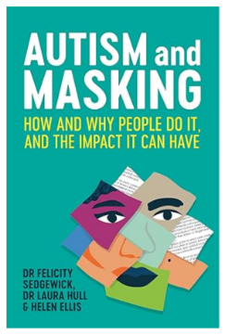
Autism and Masking: How and Why People Do It, and the Impact It Can Have

Autistic people often feel they have to present as neurotypical or perform neurotypical social behaviours in order to fit in. So-called 'masking' is a social survival strategy used by autistic people in situations where neurodiversity is not understood or welcomed. While this is a commonly observed phenomenon in the autistic community, the complexities of masking are still not widely understood.
This book combines the latest research with personal case studies detailing autistic experiences of masking. It explains what masking is and the various strategies used to mask in social situations. The research also delves into the psychology behind masking and the specifics of masking at school, at social events with peers, and at work. The book looks at the consequences of masking, including the toll it can have on mental and physical health, and suggests guidance for family, professionals, and employers to ameliorate negative effects.
With a diverse range of voices, including perspectives across gender, ethnicity and age, this is the comprehensive guide to masking and how to support autistic people who mask.

Books by Autistic Authors
(Recommended by Middletown Centre for Autism)
