

Paediatric Autism Service

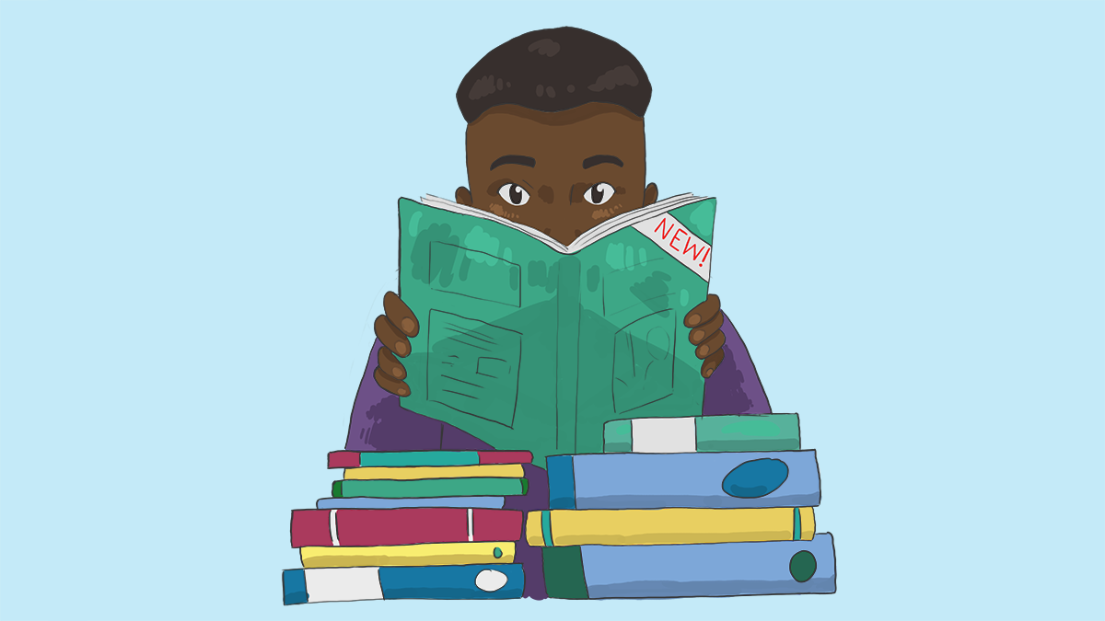

Books about emotions for children, young people and parents/carers

Worry / Anxiety
- Panicosaurus – K.I Al Ghani
This fun, easy-to-read and fully illustrated storybook will inspire children who experience anxiety, and encourage them to banish their own Panicosauruses with help from Mabel's strategies. Parents and carers will like the helpful introduction, explaining anxiety in children, and the list of techniques for lessening anxiety at the end of the book.
- The Huge Bag of Worries – Virginia Ironside
Wherever Jenny goes, her worries follow her - in a big blue bag. They are there when she goes swimming, when she is watching TV, and even when she is in the lavatory. Jenny decides they will have to go. But who can help her? A compelling picture book which can be used as a spring board into what worries children today.
- Morris and the Bundle of Worries – Jill Seeney
A charming picture book for young children in a range of situations, this story shows that talking about problems, and facing worries with the help of others is more helpful than hiding your fears. Morris the mole has a secret. He has lots of worries - in fact, a big bundle of them. The worries fill up his bedroom which means he can't sleep. Morris doesn't know what to do. There are squiggly, wriggly worries, thorny, spiky ones, and even some TERRORS, which Morris is too scared to touch. The worries float around his head, and prick his paws, and make him shiver. He's scared to tell the other woodland animals about them. But one day, Morris finds a friend who can help him, and realises that problems are easier to deal with when you've got someone to talk to. Suddenly, the worries don't seem so frightening any more.
- Willy and the Wobbly House - Margot Sunderland
This is a story for children who are anxious or obsessional. Willy is an anxious boy who experiences the world as a very unsafe, wobbly place where anything awful might happen at any time. Joe, the boy next door, is too ordered and tidy to be able to ever really enjoy life. Follow their adventures with the Puddle People who help them break out of their fixed patterns and find far richer ways of living in the world.
- Teenie Weenie in a Too Big World – Margot Sunderland
This is a story for fearful children. One day Teenie Weenie finds himself in a scrumbly screechy place. It is full of noises and crashes and things that swoop and scratch. The worse it gets, the smaller Teenie Weenie feels. After a while, he feels so small that the tiniest insect tries to eat him up. Teenie Weenie feels terrified and desperately alone. But after a while along strolls a Wip-Wop bird who invites Teenie Weenie to come and have a chocolate muffin in his tree house. With the Wip Wop bird and his friend Hoggie, Teenie Weenie learns for the first time in his life all about the power of TOGETHER. He comes to know how very different things look when it's an US not just a ME. And so after that, whenever Teenie Weenie finds himself struggling alone with something too difficult or too frightening, he goes off and finds some TOGETHER.
- A Big Day for Little Jack – Moore Inga
When Little Jack receives his first party invitation, he is very worried about going on his own. Eventually he overcomes his fears and has a great time.
- When my worries get too big – Kari Dunn Buron
Worry and anxiety are on an upswing. In fact, anxiety is the most frequent of all mental disorders in children. High levels of stress and big emotions related to social situations, sensory issues, or general frustration are common in children who live with anxiety. Such stress can lead to a loss of control, resulting in aggressive behaviour, such as screaming, throwing things or even hurting someone. Prolonged anxiety can also seriously impact success in academic achievement and cause children to avoid social and extracurricular activities.
Engaging and easy to read, this illustrated children’s book is filled with opportunities for children to participate in developing their own self-calming strategies, with evidence-based teaching activities for parents and teachers alike. Children who use the simple strategies will find themselves relaxed and ready to focus on work or play!

Anger
- When Sophie Gets Angry … Really Really Angry! – Molly Bang
Everybody gets angry sometimes. For children, anger can be very upsetting. Parents, teachers, and children can talk about it. People do lots of different things when they get angry. In this book, kids will see what Sophie does when she gets angry. What do you do?
- Everybody Feels Angry – Jane Bingham
Looks at situations that might make children angry, like being laughed at or not being able to do what one wants, and suggests ways to deal with the emotion.
- Everybody Feels Angry – Moira Butterfield
Has someone ever taken something that belongs to you? Have you ever been angry and shouted? How did you feel? Did you clench your fists? Read about Sophie and Ethan, and what they did when they felt angry. With a mix of stories, questions for the reader, and advice, this book focuses on why children may feel a certain way and how they can deal with those feelings. With fun, engaging illustrations the book reassures young readers, providing them with a vocabulary to express and understand their feelings as they grow up and encounter different situations.
- A Volcano in my Tummy – Eliane Whitehouse
Presents a clear and effective approach to helping children and adults alike understand and deal constructively with children's anger. Using easy to understand yet rarely taught skills for anger management, including how to teach communication of emotions, A Volcano in My Tummy offers engaging, well-organized activities which help to overcome the fear of children's anger which many adult care-givers experience. By carefully distinguishing between anger the feeling, and violence the behavior, this accessible little book, primarily created for ages 6 to thirteen, helps to create an awareness of anger, enabling children to relate creatively and harmoniously at critical stages in their development. Through activities, stories, articles, and games designed to allow a multi-subject, developmental approach to the topic at home and in school, it gives us the tools we need to put aside our problems with this all-too-often destructive emotion, and to have fun while we're at it.
- Mad Isn’t Bad – Michaelene Mundy
You can be good -- and angry. After all, everyone gets angry once in a while. That's normal. But what should we do with our anger? Do we have any choices? Mad Isn't Bad says children do have choices. Just as importantly, caring adults have choices about what to teach children about anger. By helping children and ourselves better understand what anger really is -- and knowing what it feels like and what makes us angry to begin with -- we can learn and teach healthy ways to handle it. Mad Isn't Bad is a book every parent, teacher, and caring adult will appreciate -- because it offers children of all ages a positive and honest view of anger -- and what to do with it.
- How to Take the Grr out of Anger – Elizabeth Verdick
Kids need help learning how to manage their anger. Blending solid information and sound advice with humour and lively illustrations, these anger-management tips guide kids to understand that anger is normal and to learn they can express it in healthy ways. The book teaches them how to recognize anger in themselves and others, how to handle situations and emotions (loneliness, guilt, frustration, fear) that lead to or mask anger, and how to deal with the anger they feel. This revised edition addresses children’s exposure to increased societal violence and includes discussion and examples of anger related to texting and social media. Young readers learn that cruelty and violence are not acceptable and there are safer, more positive ways to resolve conflicts. They also discover what to do when people around them are angry, how to get help, and how to locate other resources when they need more support.

- How Hattie Hated Kindness - Margot Sunderland
This is a story for children locked in rage or hate. Hattie lives by herself on an island. She likes sharks, and crabs and stinging centipedes. She likes anything hard and spiky. Lots of people try to bring kindness to Hattie on her island, but each time she is very horrid to them, smashing and spoiling everything they try to do for her. So after a while they all stop coming to the island. Hattie is very alone. So she sits by the water's edge and tries to figure out why she hates love and loves hate.
- A Wibble Called Bipley - Margot Sunderland
This is a story for children who have hardened their hearts or become bullies. Bipley is a warm cuddly creature, but someone has broken his heart. He feels so hurt that he decides it is just too painful to ever love again. When he meets some big tough Honks in the wood, they teach him how to harden his heart so that he doesn't have to feel hurt any more. Luckily Bipley meets some creatures who teach him how he can protect himself without hardening his heart.
- The Red Beast – K.I Al-Ghani
This vibrant fully illustrated children's storybook is written for children aged 5+, and is an accessible, fun way to talk about anger, with useful tips about how to 'tame the red beast' and guidance for parents on how anger affects children with Asperger's Syndrome.
- Cool That Volcano: How to Help Children Stay Calm, Manage Anger and Master Emotions (a book for parents)
Are your children difficult to control? Are you starting to worry that their constant temper tantrums and explosive anger are getting out of hand? You’re not alone. It is a fact that many children experience difficulties in managing their emotions, and can express anger in a damaging way that causes problems for them, and others around them. Which is where Cool That Volcano comes in. This book is packed full of techniques and methods that take you through a step by step approach to teaching your children how to manage their emotions, in a concise and easy to read manner.

Other Emotions
- A Nifflenoo Called Nevermind - Margot Sunderland
This is a story for children who bottle up their feelings. Nevermind always carries on whatever happens! Each time something horrible happens to him he just tucks his feelings away and carries on with life. Find out what happens to Nevermind and how he begins to understand that his feelings do matter, how he learns to express them and stand up for himself.
- Ruby and the Rubbish Bin - - Margot Sunderland
Ruby hates herself so much that she often feels more like a piece of rubbish than a little girl. Children at school bully her. Sometimes Ruby feels so miserable that she wants to sleep and sleep and never wake up again. Then one day, Ruby meets Dot the lunchtime lady, When Ruby feels Dot's kindness and understanding, something warm happens in Ruby's tummy. Over time, Dot helps Ruby to move from self-hate to self-respect. In fact Dot's smile makes Ruby feel like a princess. After a very important dream, and help from Dot, Ruby decides enough is enough. She finds her voice and her anger, and stands up to the bullies. She makes new friends and knows what it's like to feel happy for the first time in her life.
- The Disappointment Dragon – K.I. Al-Ghani
The fun characters in this fully illustrated storybook will help children to cope with, and discuss openly, their feelings of disappointment. There are many creative suggestions on how to banish the Disappointment Dragon and an introduction for adults explaining disappointment in children and how they can help.
- I can handle special occasions – Laurie Wright
Help your child handle the range of emotions that accompany special occasions, and provide a coping tool to last their lifetimes. Emotions are tricky and hard to handle when you’re small, and kids need our help! Mindful Mantras equip children with a necessary skill in order to cope with worries that arise during special occasions.
- Dont Let Your Emotions Run Your Life for Teens (An Instant Help Book for Teens) – Sheri Van Dijk
In this book, you'll find new ways of managing your feelings so that you'll be ready to handle anything life sends your way. Based in dialectical behaviour therapy, a type of therapy designed to help people who have a hard time handling their intense emotions, this workbook helps you learn the skills you need to ride the ups and downs of life with grace and confidence. This book offers easy techniques to help you: Stay calm and mindful in difficult situations, effectively manage out-of-control emotions, reduce the pain of intense emotions and get along with family and friends.

Loss / Bereavement
- The Heart and The Bottle – Oliver Jeffers
Once there was a girl whose life was filled with wonder at the world around her…
Then one day something happened that made the girl take her heart and put it in a safe place. However, after that it seemed that the world was emptier than before. But would she know how to get her heart back? In this deeply moving story, Oliver Jeffers deals with the weighty themes of love and loss with an extraordinary lightness of touch and shows us, ultimately, that there is always hope.
- The Day the Sea Went Out and Never Came Back – Margot Sunderland
This is a story for children who have lost someone they love. Eric is a sand dragon who loves the sea very much. Each day, he watches it going out and coming back. His sea is beautiful indeed to him. But one day, the sea goes out and does not come back. Eric waits and waits, but it does not come back. So he falls on the sand in terrible pain. It feels to him as if he has lost everything. After many bleak days, Eric sees a little wild flower. It is dying. Eric knows he must save it. He finds water. More and more flowers appear and so Eric starts to make a beautiful rock pool garden. And as he does, he finds the courage to feel the full pain of his loss, instead of closing his heart. He realises that his memories of his precious sea are like a special kind of treasure in his mind, a treasure he will never lose.

Trauma
- A Terrible Thing Happened – Margaret Holmes
This gently told and tenderly illustrated story is for children who have witnessed any kind of violent or traumatic episode, including physical abuse, school or gang violence, accidents, homicide, suicide, and natural disasters such as floods or fire. An afterword by Sasha J. Mudlaff written for parents and other caregivers offers extensive suggestions for helping traumatized children, including a list of other sources that focus on specific events.
- Alex and the Scary Things – Melissa Moses
An essential resource for professionals working with children who have experienced trauma, including social workers, counsellors, therapists, and child psychologists, as well as for parents and foster carers. Suitable for children aged approximately 4 to 8 years.

Series of therapeutic books by author:
Brian Moses books - ‘your emotions’
- I feel frightened
- I feel jealous
- I feel angry
- I feel sad
Brian Moses books – ‘your feelings’
- I’m worried
- I’m lonely
- I’m special
- I’m happy
- I’m shy
- It’s not fair
- I feel bullied
Margot Sunderland – British Child Psychologist
- The Day the Sea Went Out and Never Came Back
- Willy and the Wobbly House
- A Nifflenoo Called Nevermind
- Ruby and the Rubbish Bin
- The Frog Who Longed For The Moon To Smile
- Teenie Weenie in a Too Big World
- A Pea Called Mildred
- A Wibble Called Bipley
- How Hattie Hated Kindness
Kate Collins-Donnelly - CBT workbooks for 5-9 year olds and older young people
- Starving the anger gremlin
- Starving the anxiety gremlin
- Starving the stress gremlin
- Starving the depression gremlin
- Banish your body image thief
- Banish your self-esteem thief

