

Paediatric Autism Service





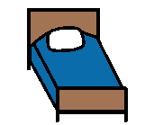

SLEEP and Autism
Information Booklet

This information booklet is designed to provide you with information to learn more about challenges your child/young person with autism may have with sleep and strategies to support them.

Point to consider

Every child is different and so are their sleep patterns. Some children require more sleep, some require less. Challenges only occur when reduced sleep is impacting on your child/young person or you e.g. your child is very tired the next day or your child is getting too old to sleep in bed with you.

Challenges children/young people with Autism may have:

Communication breakdown
Child/young person may not understand what is expected of them. They may not know the rules of what is appropriate e.g. what time to get up at. They may find it challenging to understand phrases such as “go to sleep” “go to dreamland”.

Too much information
Children with autism can have sensory differences with touch, visual stimuli or sound. This can be both distracting and distressing and make the process of falling asleep very difficult.

Social sense
Children with autism may not understanding why and when they need to sleep. Challenges with social cueing - that is learning why and in what order things should happen are common in children with autism and this may mean your child does not make the connection between their family going to bed and their own need to sleep.

Some children may find the transition from sleeping in their parent’s rooms to their own room by themselves challenging. Changes can be challenging for children with autism but it may also be the need for reassurance around bedtime and sleeping.

Allergy and food sensitivities
Children with autism are perhaps more likely than their peers to be sensitive to foodstuffs like sugar, caffeine and additives which can keep people awake. If your child frequently has sweet or caffeine-rich drinks and foodstuffs near bed time then it is worth checking whether this could be disturbing their sleep.

Lack of routine
Children/young people with autism often prefer structured routine. Without a routine, they may find it difficult to settle to sleep.

SLEEP DIARY

Sleep diaries can be useful for a number of reasons.

- They can help to establish any patterns in the child’s sleep.
- If you do decide to try any routines or strategies to help your child to sleep then the sleep diary will allow you to see if what you are doing is working consistently, sporadically or not at all.
- You can show a sleep diary to professionals involved in your child's life, such as teachers, GPs or social workers, to give them a clearer idea of the impact your child's sleep patterns are having on the child, you and your family.
- Certain benefit applications ask you to specify how much your child sleeps and how often you have to get up in the night to help them. You can send in a copy of the sleep diary to support your application.
- For some children with autism a sleep diary can act as a visual reminder of their sleep patterns. They can then be used to establish incentives for staying in bed and trying to sleep, e.g. a gold star for every night when the child doesn't get out of bed, plus a small reward if the child doesn't get out of bed for three nights in a row.

Example of a sleep diary
This should be completed every night for a week

Day & Date | Time put to bed | Time asleep | Night time wake (when/ how long) | Describe night time wake | Time awoke | Naps
Monday
Tuesday
Wednesday
Thursday
Friday
Saturday
Sunday
STRATEGIES TO HELP SLEEP

1. Bedtime routine
Visual bedtime routines are very useful no matter what age the child is, from 2 years old to 18 years old. However, the visual bedtime routine will change in style depending on the age of your child/young person.

The main routine should stay the same i.e. bedtime story, brush teeth, pyjamas on etc, but some of activities may vary e.g. board game one night, listen to music another night.

Below are some examples of visual bedtime routines for different ages. Remember to consider the language level of your child/young person as well as their age.

General advice on using a bedtime routine:

- Everyone in the house should be consistent at following the routine.
- Choose a bedtime routine and stick to it – work the routine around the chosen bedtime.
- If the child/young person takes over an hour to fall asleep, you may want to consider changing the bed time to half an hour later.
- Keep the wake up time the same everyday (may be slightly later on weekends) to encourage good sleep patterns.

Object Level

Show the child an object to represent the next stage of the bedtime routine. The object should be the same each night.


A towel for getting a bath.



A book for bedtime story.


A toothbrush for brushing teeth.



A cup for drink before bed.



A blanket for sleep time.

Photograph Level

Put up photographs of the objects in order for the bedtime routine. Take photos of your child’s bed, toothbrush, pyjamas etc to personalise the photos to your child.


Clean Teeth
Bath
Pyjamas
Read Story
Bedtime

Symbol Level

Use drawings or symbols to represent the activities to be completed in the bedtime routine. You may want to cut each symbol out and stick it (blue tack/Velcro) onto a strip of card so that once the activity is completed, it can be taken off the routine so it is clear which task the child/young person is on.


Play with toys

Get a bath

Have supper

Pyjamas on
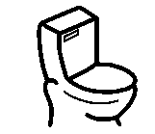
Go to toilet

Story time
Bedtime

Written Level

The bedtime routine can be written only i.e. no pictures or symbols. Written level would be appropriate for older children/young people. You may want to laminate the visual routine and have a place for the child/young person to tick off each activity as it is completed. You may also want to put a time beside each activity.

Time  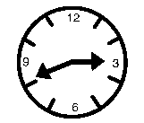 | Activity   | Completed 
9.00pm | Turn off X-box
9.15pm | Get a shower and put pj’s on
9.45pm | Have a snack – toast and milk
10.00pm | Relax: Listen to music on iPod
10.30pm | Prepare for bed – brush teeth, go to toilet
11.00pm | Bed time – lights out
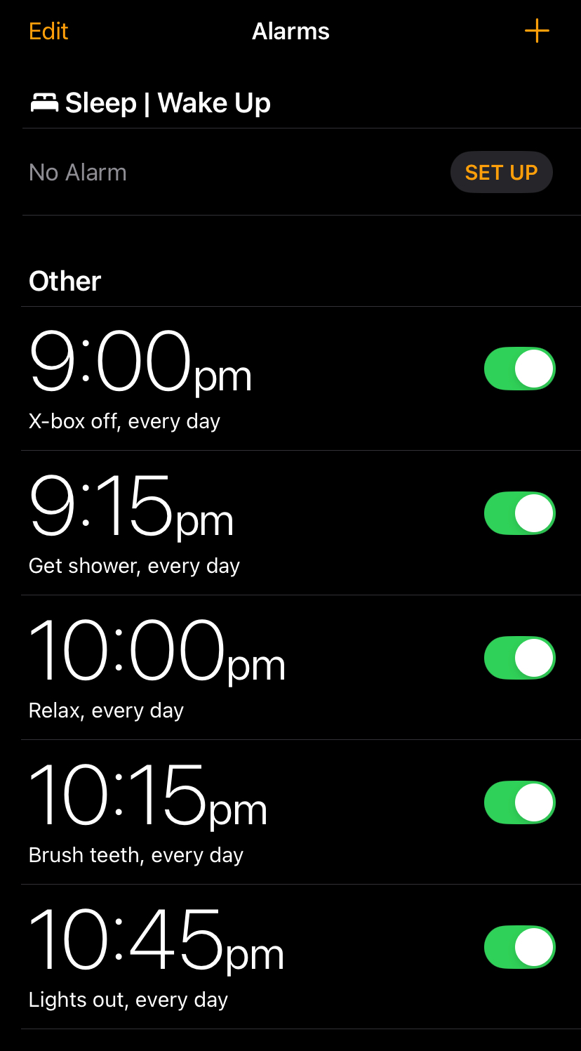

Use of phones
For young people with phones, bedtime routines could be completed using alarms or by setting reminders and repeated each night.

2. Sensory
Think about the child/young person’s room in relation to sensory information. Consider:

- Light: reduce the amount of light in the room by using dark curtains, remove night lights and turn off lights outside the door.

- 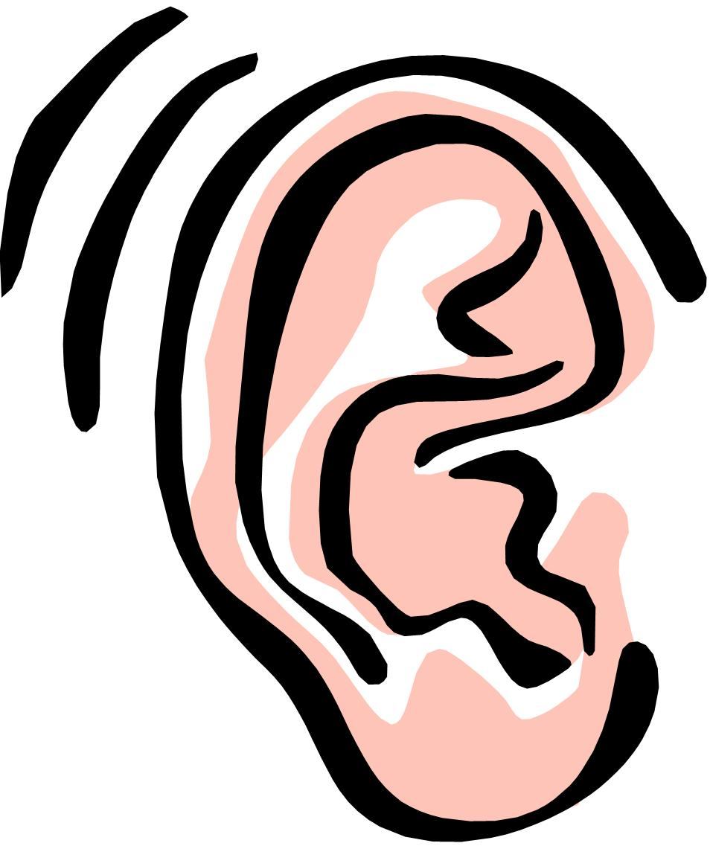Sound: Close the bedroom door, move bed position in room to a quieter area e.g. if noise is coming from one wall in room, reduce the volume on the TV in another room.

- Visual distractions: Keep the room as distraction free as possible – take down posters from the walls, turn off TVs and computers or remove completely from the room, put mobile phones out of reach e.g. in closed drawer.

- Smells: Consider the smell of the detergent used to wash pyjamas and bed clothes, think about smells coming from the kitchen or strongly scented candles/air fresheners being used in the house.

- Touch: Consider the materials of pyjamas and bed clothes, labels on pyjamas, does your child/young person prefer short or long pyjamas or a long t-shirt. Consider lying in your child/young person’s bed for a couple of hours to see if it is comfy – the mattress may be too hard or too soft.

3. Relaxation
Have a ‘quiet play time’ before bed – quiet toys, not computer games or TV. Put drops of lavender in the child’s bath. Give your child a gentle hand or foot massage. Encourage gentle exercise before bed, allowing for a ‘cool down’ period.

Remember to put the relaxation activity into the bedtime routine.

4. Diet
Limit intake of high sugar food and drinks and caffeine intake after dinner time. If you are including snacks on the bedtime routine, you may want to put down exactly what the snack is to avoid your child/young person choosing a high sugar snack e.g. write down ‘Snack – toast and milk’.

5. Exercise
Encourage your child/young person to exercise during the day. Children and adults who exercise find it easier to fall asleep at night and have deeper sleep.

Make sure the time for exercise is early in the day as stimulating exercise close to bed could make it more difficult to fall asleep. Be sure that all hard or tiring activities end 2 or 3 hours before bed.

6. Social Story
A social story can be used to explain the purpose of sleep to the child/young person. Use language such as “close your eyes” “see you in the morning” rather than “go to sleep” as this can be a challenging concept to understand. Social stories could also be used to reassure your child that they are safe when sleeping or in bed alone.

Website for examples of social stories: www.oneplaceforspecialneeds.com/main/library_social_stories.html

COMMON CHALLENGES AND STRATEGIES

Children who insist on parents' presence
Graded withdrawal:
- Lie next to child on bed for three nights
- Lie on a blanket next to the bed for three nights
- Slowly move the blanket closer to door every three nights
- Sit on chair in the bedroom at the door with door open for three nights
- Sit outside door whilst still visible to child for three nights
- Sit outside the door, not visible to child for three nights
- Sit outside the room with door closed for three nights.

For night waking
Scheduled awakening:
- From the sleep diary you have recorded, see when the child wakes up during the night
- Set an alarm clock for 30 minutes before this
- Wake the child and allow them to fall back to sleep
- If the child doesn't fall back to sleep try waking 45 minutes before on the next night and experiment until you find the best time.

To ensure your child is sleepy at bed time
Restricting sleep:
- From sleep diary, see average hours of sleep per night
- Calculate 90% of this and make this the new sleeping time (delay bedtime and/or waking time); never restrict below five hours
- If lying awake, occupy in another room until sleepy
- Avoid naps in day/oversleeping at weekend
- After a week, move settling/waking time by 15 minutes - continue until desired pattern of sleep occurs.

TOP TIP

Be consistent. Your child will learn most quickly if you are consistent with the strategies you are using e.g. resettle them back to sleep in the same way when they wake or have the same bedtime routine every night.

HOW MUCH SLEEP DOES MY CHILD NEED?

The amount of sleep a child need depends on the individual and certain factors such as the age of the child. Below are some general guidelines:

Age | Hours sleep required | Bed time | Wake up time | Additional comments
1 – 3 years old | 12 – 14 hours | 7pm to 9pm | 6am to 8am | Most children at this age will have a nap during the day lasting 1-3 ½ hours.
3 – 6 years old | 10 – 12 hours | 7pm to 9pm | 6am to 8am | Naps are becoming shorter at 3 years old and stopping by 4 years old.
7 – 12 years old | 10 – 11 hours | 7:30pm to 10pm | 7am to 8am (for school) | There is variation in bedtimes at this age. This is due to social, school and family activities. The average length of sleep for this age group is 9 hours.
12 – 18 years old | 8 – 9 hours | 10pm or later | 7am to 8am (for school) | Bed time is getting later. Social pressures often conspire against teenagers getting the appropriate amount of sleep.
(Source: WebMD, 2008)
What if I have tried these strategies but my child/young person’s sleep has not improved?

If you have tried the suggestions above in a consistent manner and over a period of time, but there have been no positive changes to your child/young person – you may want to speak to your GP or a Paediatrician (if your child attends for Paediatric review).

Resources:

‘Gro Clock’ – available on Amazon is a useful and visual tool to encourage positive sleep routines (particularly for younger children).

Paediatric Autism Service Podcast:

The Paediatric Autism Service has a podcast series “Exploring Autism” aimed at parents and carers of autistic young people. They are presented, recorded and published by the Paediatric Autism Service and address a variety of topics, including sleep

The podcasts can be accessed by searching “Exploring Autism with the Northern Trust” on the relevant podcast platform (Spotify, Apple podcasts or Google podcasts), or by following the direct links on the Northern Health and Social Care Trust website, under the Paediatric Autism Service (found in A-Z of services).

Websites:

Here are some useful websites which contain information on promoting sleep.

- www.sleepscotland.org
- www.thechildrenssleepcharity.org.uk
- www.middletownautism.com
- www.autism.org.uk

Paediatric Autism Service
The Cottage
5 Greenmount Ave
Ballymena
BT43 6DA

Tel: 028 2563 3777

