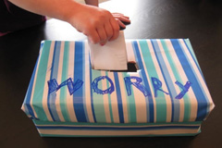 What is a worry box? 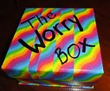
A Worry Box helps children put their worries in a special place (where parents can keep the worries for them) so that they can be relieved of those worries at night (or during the day). A worry box aims to take the worry and anxiety off of your child, and places it an item such as a box/jar/sock. This simple strategy will give your child the chance to put away their worries at night and sleep a little easier.
How it works: Firstly create the box - Involving your child in making & decorating their worry box will help your child to feel some sort of ownership over the activity, as well as deciding how the box should look. Where possible use your child’s interests in the decoration of the box.
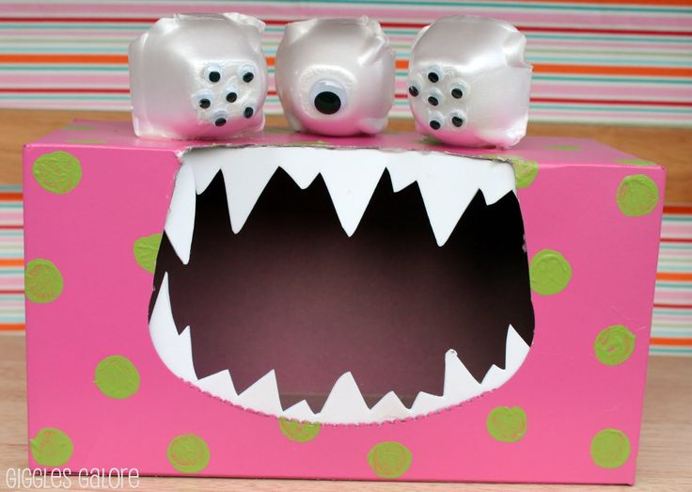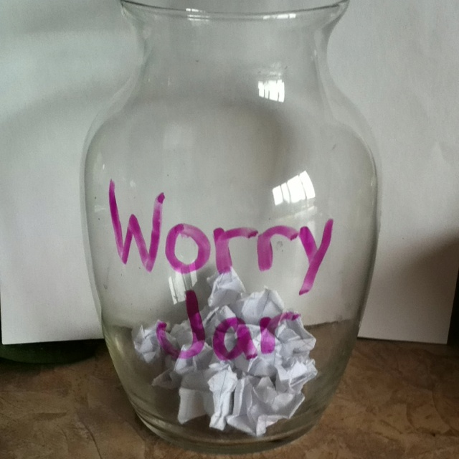
Talk about it: Explain to your child that this is a special place where they can put away their worries each night, and that you will take care of those worries for them each night. ‘Worries’ that your child is experiencing are written down onto strips of paper which are then folded and added to the worry box. Depending on your child’s abilities and age, adult help may be required in writing down the worries. If this is the case, it is helpful to also allow your child to draw a picture of whatever is being written down.
Put away the worries: Find five minutes each night (preferably before the bedtime story) where you and your child can discuss their worries from the day. Older kids can write their own, but parents should write one worry per piece of paper as your child describes them. Proceed slowly. Allow your child to place each worry in the box before you write the next one down. After you’ve written down the worries for the night, help your child place the box in the identified safe place. As they settle into sleep, remind your child that you will keep their worries safe so that they can be worry-free at night.
Discuss the worries: Every day (or however often is deemed appropriate), you and your child can check in with each other through the use of the worry box. For example, begin by having your child take out one strip of paper at a time. The strips of paper with worries written on them serve as excellent visuals to start conversation & to discuss the worries. Through discussion, your child will indicate whether or not that particular worry is still causing them anxiety. If that is the case, your child can fold the paper back up and place it back into the box. If your child feels as though this is not something that is a worry anymore, the child and adult can discuss a way for disposing of the paper. For example, maybe the child would like to rip it into several pieces and throw it away. Other children may want to stomp on the paper and then throw it away.
The Worry Box works well for children ages 3-12.

