Paediatric Psychology Support for Families Living with Epilepsy
Receiving a diagnosis of epilepsy may bring with it a range of emotions for your family. Whilst at times life may go on as usual, or you may feel confident as regards living with epilepsy in your family, at other times, frustration, anxiety and any number of other feelings may be around.
For both your young person and all of your family, life may now include changes that you never expected. Amongst these changes will be managing medication, juggling appointments, learning relationships with healthcare professionals, possibly discussions with family, friends and school about epilepsy, and learning to negotiate the different stages of growing up, with epilepsy in the picture.
We know that growing up can, on its own, bring about challenges for any family. We also know that managing a long-term health condition can be an added stressor. Therefore, as part of our epilepsy service we offer the opportunity to avail of support for the emotional (as well as physical) well-being of your family. This is not to say that difficulties are inevitable; however, it is important to know that supports are available to your family if you ever feel they may be beneficial.
When might it be helpful to speak with a Psychologist?
You are always welcome to link in with our team Psychologist at any time if you have a worry or a question about the emotional well-being of your family. There may be times however that it seems unclear as to what our role may be with your family, or how we may be helpful. The role we may play in supporting your family may change as your child grows up, or depending on the age in which they receive their diagnosis. It can be useful, therefore, to think about the range of supports that we can offer, and some of the issues that may present for some families at different age stages.
What you might notice across the years….



Babyhood – Toddler / Young Childhood
How might Epilepsy impact at this age?

Your child will be too young to understand much about their epilepsy at this age. There may, however, still be challenges that can present; for example
- Taking medication, which can often become a battle (and be very exhausting) for both parents and their child.
- The understandable stress that may be around for parents; for example in adjusting to what is a new experience for your family, or in trying to keep routine for your family at a time of change.
- A diagnosis of epilepsy may bring with it feelings of sadness, worry for the future, or uncertainty as to how to cope for parents.
- For siblings, who may find it an adjustment when a brother or sister has experienced seizures, or has just received a diagnosis. They may also have worries or questions as they become aware of the impact epilepsy may have for their sibling. Or they may feel natural frustration or resentment if they perceive “the rules” at home to be different for their sibling than for themselves. They may feel guilty for feeling this way.


Middle Childhood
How might Epilepsy impact at this age?
Middle childhood is a time for figuring things out and how they work; including understanding rules and boundaries (and how to test them!), developing their own opinion (and learning to understand that others have opinions too…) and recognising themselves in comparison to others. Here are some of the challenges that may present…
- Things might feel unfair; like having to take medication, not being able to participate in certain activities, or having to miss events to go to hospital. Especially if friends are not having to do these things.
- At this age it’s not always easy to name feelings and let others know why the feelings are around. Difficult feelings are therefore often communicated through behaviour change; testing boundaries, or appearing sad, worried, or withdrawn.
- Depending on how epilepsy presents for your young person, school may be a place that can feel difficult.
- It may be a challenge for parents to manage the busy-ness of parenting a child with all that epilepsy management requires. Things may feel overwhelming at times.
- Parents may have worries for their child that feel harder to manage as their child gets older.
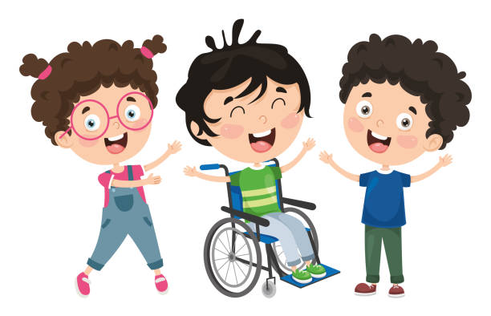


The Teenage Years
How might Epilepsy impact at this age?
Adolescence is all about emerging independence and learning through experimentation with new things. This can be an interesting time for both the young person and for parents. With epilepsy in the picture, negotiating these years can have an added challenge. Some of the issues that may present include…

- The young person may naturally feel resentful of their health condition, and wish to avoid thinking about it. This may result in their desire to avoid medication and to avoid contact with anyone who represents epilepsy for them; including their healthcare team.
- Finding a way to allow the young person to engage fully in the experience of being a teenager, without epilepsy getting in the way.
- Figuring out the process of the young person becoming independent in managing their epilepsy care; this can be a worrying time for parents, and a frustrating time for young people living with epilepsy. Negotiating the boundaries can be a challenge for everyone.
- Preparing the young person for adulthood and adult services; what we call “transition”. Transition is a process, and involves including the young person in learning about their epilepsy and in becoming involved in the tasks that this involves.

How might a Psychologist help?
We provide a safe and confidential space for parents and young people to talk about their experience of epilepsy and their emotional well-being. We aim to help families understand and manage difficulties that may present for them and offer support.
Psychology is part of your epilepsy care as we know that it is important to look after our emotional as well as physical health. You may meet the Psychologist as part of your routine attendance at the Epilepsy Clinic.
If you would like to speak with the team Psychologist, just let us know!

The Paediatric Epilepsy Team

