What is “Anxiety”?
Here are a few things to remember about anxiety;
- Anxiety is a completely normal feeling
- Everyone feels anxious at times
- Anxiety is our body’s way of keeping us safe; therefore anxiety can be very important

HOWEVER, anxiety can also have its down-sides…
- It can feel unpleasant; we can feel sick, dizzy, or find it hard to breathe
- It can interrupt us at times when it doesn’t need to, which can be annoying and upsetting
- It can make us act in ways that we don’t feel good about

So, even though anxiety is a very natural feeling, and can (at times) be quite helpful, it is also important that we figure out ways that work for us to be able to control anxiety when we don’t want it around.
The 1st step to learning ways to control feelings of anxiety is to understand why and how anxiety happens.

Why is Anxiety sometimes important?
It might be useful to think of anxiety as your bodys
alarm system!!
An alarm system lets us know when we might be in danger and when we need to get ready to do something to keep ourselves safe (think, fire alarm). So for example…

If you smell smoke You feel fear You get out of the
in the house & Anxiety house quickly

You think Your body reacts;
“I’m in Danger” (heart beats fast,
body ready to move)

So, you can see how in this situation anxiety is really helpful!!
Other times when people might feel anxious are: before a test or exam, or just before a sports match or competition. A little bit of this anxiety (although still not pleasant) can be useful;
- It keeps our brains alert and focussed & keeps us watchful
- It gets our body and muscles ready to move
Can you think of times when some anxiety has been helpful for you?
____________________________________________________________________________________________________________________________________________________________________________________________________________
So how does Anxiety connect our brain and our body?
When our anxiety alarm goes off, this makes 3 things happen;

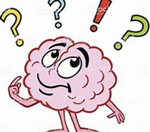
We start to have lots of anxious THOUGHTS, like
“I’m in danger!” or “Something awful is going to happen” or “I can’t cope with this situation; this is out of my control”

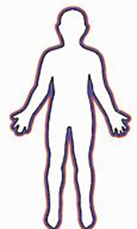
Kkkk Our BODY starts to react to these thoughts, getting
us ready to cope with the danger we think is coming.
To do this, it produces a flood of chemicals, such as
adrenaline. As our body gets “ready”, we might feel
Racing heart Muscles get tense Shaky/Dizzy
Breathing gets shallow Sick tummy Feel hot/cold

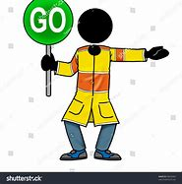
We take ACTION. So we do something to cope with the danger we think we are facing. This makes sense! Some of the things we might do are
Run away Hit Out Scream
Cry Freeze Hide
(You might have heard of Fight (take action)/ Flight (run away or avoid)/ Freeze (shut down)?)
Doesn’t it make sense then that if we think we are in danger, then our mind and body will want to protect us, and we will take action to keep ourselves safe?
Can you think of a time when you felt anxious/worried/scared?
- What were your thoughts at this time
____________________________________________________________________________________________________________________________________________________________________________________________________________

- Did you notice what happened in your body when you felt this way?
____________________________________________________________________________________________________________________________________________________________________________________________________________

- Can you remember what you did to try to cope?
____________________________________________________________________________________________________________________________________________________________________________________________________________

Even though anxiety is very normal and can (at times) be helpful, it can also get in the way and make it difficult for us to do the things we want to do; or do the things we know we have to do…

