




Adult Support Worker Band 3
Job Description



The Northern Health and Social Care Trust (NHSCT) is responsible for the delivery of safe and effective health and social care (HSC) services to the population of the Northern Trust area in Northern Ireland.
We provide compassionate care with our community in our community. In order to do this we require the commitment of a highly skilled and professional workforce that meets the need of the service.
The diagram below outlines our values and our objectives which support the delivery of compassionate care within our community.
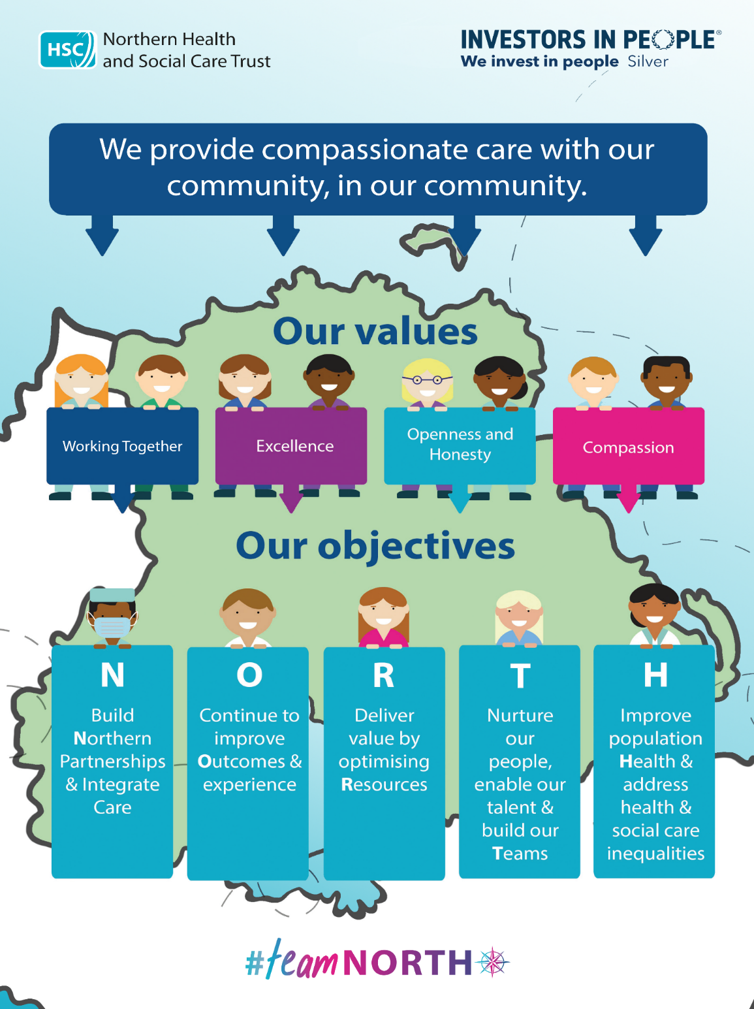

The below diagram details the values and associated behaviours that we expect staff working within Health and Social Care (HSC) to display at all times;

HSC Value | What does this mean? | What does this look like in practice? - Behaviours
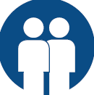  Working Together | We work together for the best outcome for people we care for and support. We work across Health and Social Care and with other external organisations and agencies, recognising that leadership is the responsibility of all. | - I work with others and value everyone’s contribution  - I treat people with respect and dignity  - I work as part of a team looking for opportunities to support and help people in both my own and other teams  - I actively engage people on issues that affect them  - I look for feedback and examples of good practice, aiming to improve where possible
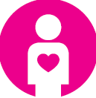  Compassion | We are sensitive, caring, respectful and understanding towards those we care for and support and our colleagues. We listen carefully to others to better understand and take action to help them and ourselves. | - I am sensitive to the different needs and feelings of others and treat people with kindness  - I learn from others by listening carefully to them  - I look after my own health and well-being so that I can care for and support others
  Excellence | We commit to being the best we can be in our work, aiming to improve and develop services to achieve positive changes. We deliver safe, high-quality, compassionate care and support. | - I put the people I care for and support at the centre of all I do to make a difference  - I take responsibility for my decisions and actions  - I commit to best practice and sharing learning, while continually learning and developing  - I try to improve by asking ‘could we do this better?’
  Openness & Honesty | We are open and honest with each other and act with integrity and candour. | - I am open and honest in order to develop trusting relationships  - I ask someone for help when needed  - I speak up if I have concerns  - I challenge inappropriate or unacceptable behaviour and practice

JOB DESCRIPTION

JOB TITLE: Adult Support Worker

BAND: 3

DIRECTORATE/DIVISION: Mental Health, Learning Disability and Community Wellbeing

INITIAL LOCATION: Hollybank Short Break Service and Hollybank Supported Living Service
REPORTS TO: Manager and Deputy Manager and on a daily basis report to the Senior Officer on Duty

ACCOUNTABLE TO: Head of Service and Director of Mental Health, Learning Disability and Community Wellbeing Services

FLEXIBLE WORKING
PROVISIONS AVAILABLE: Full- time working, Part-time working, Bank

JOB SUMMARY:
Support adults with a learning disability within Short Break Services in Hollybank and or Supported Living Services within the geographical area. Work as a member of a multidisciplinary team under the direction and supervision of management staff.

KEY RESULT AREAS / MAIN RESPONSIBILITIES
- Helping to create a relaxed and homely environment which will maintain and enhance the quality of life for each individual service user, and which maximises opportunity for choice and self determination.
- To assist/support service users with practical day to day living tasks. To promote independent living opportunities for all service users
- Supporting service users to plan social and leisure activities and to accompany them as appropriate.
- To provide transport as required for service users in your own vechile, service user’s vechile or Trust transport.
- To implement, monitor, review and evaluate care and support plans/person centred plans in partnership with service users, their families/carers and others involved.
- To work with service users who may have complex health needs. To attend relevant training and be competent in appropriate action required.
- To ensure the health, safety and welfare of service users in paramount at all times.
- Ensure that the procedures of the Trust are adhered to in respect of handling and security of money, reporting to the Senior Officer on duty, untoward events, e.g. falls, accidents, unusual behaviour etc. Complaints and maintaining records of same, Health & Safety Regulations, Fire Prevention.
- Contribute to the maintenance of records as required by the Trust.
- Attend and contribute to staff, group meetings or other meetings arranged by the Trust.
- Participate in a programme of formal supervision.
- To work effectively with service users who may display some behaviours which concern/challenge.
- To follow care plans in accordance with instruction from senior staff.
- To attend specific training courses and implement agreed behaviour management plans.
- To develop the use of community based resources to compliment building based activity.
- Support Service Users to access community facilities, transporting Service Users using own vehicle.
- To continually develop own professional competencies and practice.
- Helping to develop and maintain effective communication links within the community, other professional and family networks.
- To work within a flexible duty rota involving 7 day week cover including weekend cover, waking night duty and sleepovers both within the Short Break Service and Supported Living Service.
- Comply with all instructions in regard to infection prevention and control.
GENERAL RESPONSIBILITIES
Employees of the Trust will be required to promote and support the mission and vision of the service for which they are responsible and:-
- At all times provide a caring service and to treat those with whom they come into contact in a courteous and respectful manner

- At all times demonstrate practice the HSC values of Working Together, Excellence, Openness & Honesty and Compassion

- Carry out their duties and responsibilities in a manner which assures patient and client safety

- Comply with all instructions in regard to Infection Prevention and Control

- Demonstrate their commitment by their regular attendance and the efficient completion of all tasks allocated to them

- Comply with the Trust’s Smoke Free Policy

- Carry out their duties and responsibilities in compliance with health and safety policy and statutory regulations

- Adhere to equal opportunities policy throughout the course of their employment

- Ensure the ongoing confidence of the public in service provision

- Adhere to the Code of Conduct for HSC Employees which aims to guide staff, managers and employers in the work that they do and the decisions and choices they have to make. Professional staff are expected to follow the code of conduct for their own professions as well as this code.

- The post holder will promote and support effective team working, fostering a culture of openness and transparency. The post holder will ensure that they take all concerns raised with them seriously and act in accordance with the NHSCT Raising Concerns Policy and their professional code of conduct, where applicable.

RECORDS MANAGEMENT
All employees of the Northern Health & Social Care Trust are legally responsible for all records held, created or used as part of their business within the Northern Health and Social Care Trust, including patient/client, corporate and administrative records whether paper based or electronic and also including e-mails. All such records are public records and are accessible to the general public, with limited exceptions, under the Freedom of Information Act 2000, the Environment Regulations 2004, the General Data Protection Regulations (GDPR) and the Data Protection Act 2018. Employees are required to be conversant and to comply with the Northern Health and Social Care Trust policies on Information Governance including (for example) the ICT Security Policy, Data Quality and Data Protection Policy and Records Management Policy and to seek advice if in doubt.

SALARY
£24,973 - £26,598 per annum pro-rata

RIGHT TO WORK IN THE UK
Please note this role may not meet the requirements for a Skilled Worker visa (including a Heath and Care Worker visa) and the Trust therefore would be unable to employ anyone that requires Sponsorship. For further information visit the UK Visas and Immigration website (https://www.gov.uk/government/organisations/uk-visas-and-immigration).

HOURS
Normal full-time hours of duty are 37½ hours per week, exclusive of meal times

MEDICAL
Appointment will be subject to a successful pre-employment health assessment.

HOLIDAYS
27 days each year; 29 days after 5 years’ service; 33 days after 10 years’ service and 10 statutory and public holidays.

PENSION
The post-holder can participate in the Health Social Care Pension Scheme.

NORTHERN TRUST BENEFITS
You can explore the benefits on offer to you in the Northern Trust by clicking here

PROBATIONARY PERIOD
You will serve a probationary period of normally six months.

WAITING LIST
A waiting list may be compiled for similar permanent/temporary, full/part time, bank posts which may arise within the next 12 months in Hollybank Short Break Service and Hollybank Supported Living Service
PAY PROTECTION
Legacy Trust Staff who apply for a promotion after 1 April 2011 should be aware that they will lose their legacy protection arrangements and will be entitled to pay protection in accordance with circular HSS (JNF)(1) 2011. This circular will also apply to legacy staff who are currently in receipt of protection and who move post on promotion.

Completed application forms should be returned to the BSO Recruitment and Selection Shared Services Centre, on or before the closing date as stated in the advertisement.

Canvassing, either directly or indirectly, will be an absolute disqualification.

We will review this Job Description and it may include any other duties and responsibilities we determine in consultation with the jobholder. We do not intend it to be rigid and inflexible but rather to provide guidelines within which the jobholder works.

Jan 2026


PERSONNEL SPECIFICATION

Title of Post: Adult Support Worker
Band of Post: 3
Notes to applicants:
- You must clearly demonstrate on your application form under each question, how you meet the required criteria as failure to do so may result in you not being shortlisted. You should clearly demonstrate this for both the essential and desirable criteria.
- Shortlisting will be carried out on the basis of the essential criteria set out in Section 1 below, using the information provided by you on your application form.
- Proof of qualifications and/or professional registration will be required if an offer of employment is made – if you are unable to provide this, the offer may be withdrawn.
- Volunteering experience may be considered appropriate in particular for roles within the context of direct patient/client care.
ESSENTIAL CRITERIA

SECTION 1: The following are ESSENTIAL criteria which will initially be measured at shortlisting stage although may also be further explored during the interview/selection stage. You should therefore make it clear on your application form whether or not you meet these criteria. Failure to do so may result in you not being shortlisted. The stage in the process when the criteria will be measured is stated below.
Factor | Criteria | Method of Assessment
Qualifications/ Registration  Experience | - NVQ or QCF Level 2 in care  OR  - GNVQ/BTEC National Certificate or Higher Qualification in Care  OR  - 6 months paid or unpaid caring experience | Shortlisting by Application Form
Other | Hold a current full driving licence which is valid for use in the UK and have access to a car on appointment. This criteria will be waived in the case of applicants whose disability prohibits driving but who have access to a form of transport approved by the Trust which will permit them to carry out the duties of the post. | Shortlisting by Application Form
SECTION 2: The following are ESSENTIAL criteria which will be measured during the interview/ selection stage:
Skills / Abilities | - Ability to sensitively undertake all personal care tasks.  - Clear verbal and written communication skills.  - Ability to work as part of a team | Interview / Test
Knowledge | - Understanding of the role and responsibilities of the job.  - Ability to understand and implement behaviour management plans. | Interview / Test
Other | - Willing and able to work flexible hours as the service demands including sleepovers and waking night duty.  - Permanent appointees who do not hold at least NVQ Level II or equivalent, will be appointed on the condition that they will successfully complete the QCF /RVQ Level 2, in a timescale agreed by management.  - As part of your role you will be required to work with individuals who display varying levels of challenging behaviour or complex health care needs. You will be required to attend relevant training and implement where require
Value Based Recruitment
Value Based Recruitment is a process adopted by the Northern Trust to attract and select employees on the basis that their individual values and behaviours align with those of the Trust.
It focuses on the ‘how’ and ‘why’ people do what they do.
Candidates who are short-listed for interview will need to demonstrate at interview that they have the required knowledge, skills, competencies and values to be effective in this new role.
In answering the value based questions you have the opportunity to share examples of when you have demonstrated values relevant to the Northern Trust.

Criminal Offences, Investigations and Charges
Having a criminal record will not necessarily debar you from working with the Trust. This will depend on the nature of the position, together with the circumstances and background of your offences or other information contained on a disclosure certificate. Where it is necessary to obtain an Access NI disclosure the Trust operates in line with the Access NI Code of Practice (www.nidirect.gov.uk/publications/accessni-code-practice).

If you require further information or a copy of the policy on the recruitment of ex-offenders or the policy on the Secure Handling, Use, Storage and Retention of Disclosure Information, please contact the Trust Human Resources Department.

As part of the Recruitment & Selection process it may be necessary for the Trust to carry out an Enhanced Disclosure Check through Access NI before any appointment to this post can be confirmed.

THE NHSCT IS AN EQUAL OPPORTUNITIES EMPLOYER
Successful applicants:
- may be required to attend for a Health Assessment
- can expect to be placed at the minimum point of the pay scale, although a higher starting salary, within the range of the pay band may be available if the person appointed has experience relevant & equivalent to the post. If the successful candidate is an existing HSC employee moving to a higher band, AfC Pay on Promotion will apply.
- have the right to request Flexible Working from the 1st day of their employment. A number of flexible working provisions are offered by all HSC Organisations including Full-time working, Fixed working patterns, Part-time working, Flexi-time, Compressed/elongated hours, Average hours working patterns, Term-time working, Job-share or Homeworking for some or all of the working pattern, depending on the role being undertaken. Successful applicants are encouraged to discuss with their manager what Flexible Working provisions may be available in the role they are taking up, prior to commencing employment, to help them achieve a positive Work/Life Balance.
Jan 2026


