
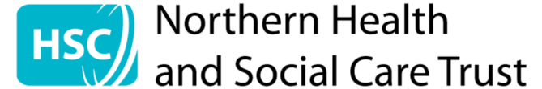
Consultation Document
February 2026
Draft Carer Strategy
2026 - 2031
Enter text here
Example title

Foreword from the Director of Strategic Planning, Performance and ICT

Northern Health and Social Care Trust recognises the significant contribution carers make, both to those they care for and to the wider community. Our Carers Strategy reaffirms our commitment to carers by setting out an approach to supporting our carers as they continue in their caring role, while not compromising their own health and well-being.

There are over 220,000 unpaid carers in Northern Ireland with over 56,000 in the Northern Trust area. As a Trust we have been supporting carers for many years, and while much has been achieved, we need to look forward and continue to consider and involve carers.


As laid out in the Trust’s Corporate Plan 2024-2028, the Trust is committed to supporting and involving carers. Carer involvement is important in all we do and we will ensure that carers’ voices are heard when developing specific support and resources.

As part of our commitment to supporting and involving carers we have two forums in Northern Trust: our Carer Listening Forum and the Carer Pathway Steering Group. The Carer Listening Forum is facilitated by our Chief Executive and Trust Chair, who have committed to meeting biannually with unpaid, family carers including young carers, to better understand how we can meet their needs. The Carer Pathway Steering Group is carer-led, Chaired and Co-Chaired by two carers, and has staff representation from across our operational Divisions.

In developing this strategy, our engagement commenced with carers back in January 2024 through our Carer Pathway Steering Group, with carers completing a survey to ascertain important themes across our programmes of care. We continued this engagement with carers at the first meeting of the Carer Listening Forum in March 2024, with the findings of the survey collated into themes and presented to the Forum to help inform discussion around the way we would work to take action.

At a regional level, the Department of Health commissioned a review of the ‘2006 Caring for Carers Strategy’ and in January 2025, the Northern Trust’s Carer Pathway Steering Group had the opportunity to engage with the reviewers from the HSC Leadership Centre. They heard from our carers and staff on various recommendations in the original 2006 Strategy and discussed what works well, what could be improved on and challenges that affect services. The outworkings of these discussions resulted in a number of regional themes or priorities.

In June 2025, during Carers week, we held a ‘Caring about Equality’ conference with over 150 carers in attendance and again used this opportunity to engage with carers on ‘what matters to them’ by asking them, “What would make an impact on your caring role?”

Each time we asked, you told us what matters to you and we found many similar themes arising, whether the response was from an individual, collective, or regional perspective.

In September 2025, we then presented the themes from carers to our staff and asked them what we currently do in relation to each theme, what could we do differently and what support do staff need to do things better or differently. The aim was to combine staff input with carer themes to inform new priorities for the Carer Strategy (2026-2031) and in doing so, developing a shared responsibility in planning a way forward.

It is these priorities, identified by carers and staff, that we would like to take forward as the focus of our new Carer Strategy and which will directly inform a Delivery Plan outlining the steps necessary to achieve the specific priorities, detailing the actions, timelines and responsibilities required for successful delivery over the next five years. We hope you will let us know your thoughts on the draft strategy.
Neil Martin
Director Strategic Planning, Performance and ICT

About the Trust

The Northern Health and Social Care Trust (the Trust) was established on 1 April 2007 under the Northern Health and Social Services (Establishment) Order (Northern Ireland) 2006.

The Northern Health and Social Care Trust provides a range of health and social care services to a population of approximately 479,000 people across a geographical area of 1,733 square miles (2,773 square kilometres), making it the largest geographical Trust in Northern Ireland. The Trust covers four local council areas – Antrim and Newtownabbey, Causeway Coast and Glens, Mid and East Antrim and Mid Ulster.

The Trust has the largest older population and the largest population of children when compared to other Trusts in Northern Ireland. There are approximately 56,000 informal, unpaid carers in the Trust area according to the 2021 Census.

Map showing the Northern Health and Social Care Trust area

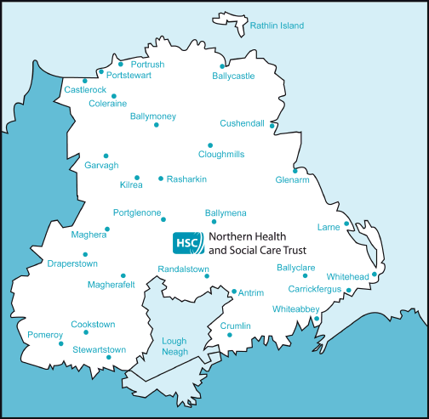

Services are delivered from over 150 facilities including two major general hospital sites, a mental health hospital, local community hospitals, health centres, social services and a significant network of community services as well as provision of care in the home. Delivering safe and effective services which are accessible and responsive to the needs of patients, clients and carers is central to the Trust’s role.

Our vision

The Trust’s vision is ‘to provide compassionate care with our community, in our community’. In delivery, planning and reforming services, all staff are guided by the Health and Social Care Values for All – Working Together, Excellence, Openness and Honesty and Compassion.

Who is a carer?

The Carers and Direct Payments Act (NI) 2002 defines a carer as ‘an individual, aged 16 or over, who provides or intends to provide a substantial amount of care on a regular (informal) basis.’

It is important to distinguish informal, unpaid family carers from paid care workers. Carers provide unpaid care alongside their other responsibilities, with many putting their lives on hold to provide care for a friend, neighbour or relative. This care could be for a few hours a day or more, and could be around the clock care.

Why are we planning a new Carer Strategy?

Our first strategy was developed in 2012, with an Action Plan being renewed every three years, but since then, the needs of carers and the impact of caring has been greatly emphasised. Our last Action Plan, developed in 2022, focussed on rebuilding carer support coming out of the pandemic and focussed on the Carer Hub as a central point of contact for carers and staff.

We believe following local engagement and the regional review of ‘Caring for Carers 2006’ that now was the right time to develop a new Carer Strategy and subsequent Delivery Plan for the next five years.

The draft Northern Trust Carer Strategy is based on the key themes that local carers have told us are important to them:
- Identification and recognition of carers
- Information
- Communication
- Navigating Health and Social Care
- Carers’ own health and Advocacy
- Transitions

What do we wish to achieve?

The draft Strategy has been shaped by adult and young carers, who have shared their stories and realities with us and who agreed the key themes (as above) to inform the Strategy.

Building on the themes identified by carers and informed by staff input, we have established new strategic priorities for the next five years (2026-2031) underpinned by a shared responsibility for implementation.

Through these key priorities we want to see a carer’s journey through the Trust systems be more streamlined and connected.

How do we plan to achieve this?

The Carer Listening Forum and Carer Pathway Steering Group form part of an accountability structure in the Trust.

Along with the Northern Partnership and Population Health Committee, on which carers are also represented, the strategic implementation of aspects of the key priorities will be overseen.

Impact on carers

We expect that the benefits and positive impact on carers will include the following:

- Increase in the number of carers being recognised and identified by staff, family members and carers themselves
- Information for carers being up to date and relevant, and available in multiple formats across services
- Communication between carers and services improved, and communication between services improved, increasing carers confidence in services
- Navigation through the Trust improved with clearer pathways developed and signposting to relevant supports being clear
- Carer’s own health and wellbeing being supported whether physically or emotionally, carers having the opportunity to access advocacy services if needed
- Transitions being a smoother and seamless process with carers and family members being involved from the outset

Promoting equality and rural needs

The Northern Trust is committed to promoting equality of opportunity, good relations and human rights in all aspects of its work. In keeping with the commitments in our Equality Scheme we have carried out an equality screening of this proposal the outcome of which was to subject the implementation of the proposal to ‘on-going screening’. At this stage, no major adverse impacts have been identified and the outcome of this proposal will result in positive impacts on Section 75 groups. This screening will be kept under review.

The Rural Needs Act 2016 requires the Trust to have due regard to rural needs when developing plans, and when designing and delivering public services. The Trust has also carried out a Rural Needs Impact Assessment.

A copy of the equality screening template and Rural Needs Impact Assessment can be found on the Trust’s website www.northerntrust.hscni.net

The Trust invites views on these assessments and will consider all feedback received during the consultation period.

Tell us what you think

We are consulting with you on the Northern HSC Trust’s Draft Carer Strategy.

Please take the time to read through the draft Carer Strategy. There is additional supporting information available online. The feedback on this consultation will help us to understand if the Strategy has any gaps or if we need to consider any further options before it is finalised in 2026.

We want to consult as widely as possible on our draft Strategy and the findings of our Equality Screening, and Rural Needs Impact Assessment (RNIA) over a 12-week period commencing 27 February 2026 and ending 22 May 2026.

To facilitate your feedback, a consultation proforma is available online. To request a copy of the proforma for you to fill in at home or to arrange to complete it with a member of staff, email InvolvingYou@northerntrust.hscni.net or telephone 028 2766 1377.
We welcome your feedback in any format by the closing date of 22 May 2026.
If you have any queries or comments regarding this consultation document, Equality Screening, or RNIA and their availability in alternative formats (including Braille, disk and audio cassette, and in minority languages to meet the needs of those who are not fluent in English) then please contact:

Involvement Team
Route Complex
8e Coleraine Road
Ballymoney
Co Antrim
BT53 6BP
Tel: 028 2766 1377
E-mail: InvolvingYou@northerntrust.hscni.net

In compliance with the legislation, when making any final decision the Trust will take into account the feedback received from this consultation process. A consultation feedback report will be published on the Trust website.

